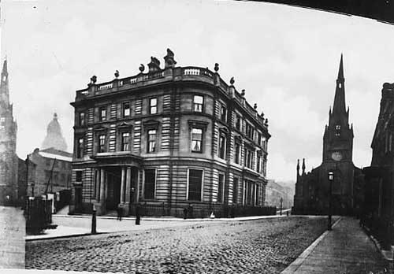

Undated, Print in the early 1900's looking along Park Row to St Anne's Cathedral built in 1837-8. It was replaced in 1902-4 by the present St Anne's Cathedral. On the left is the Bank of England opened in 1864, designed by Phillip Hardwick. The building still stands and now a bar in the old vaults.
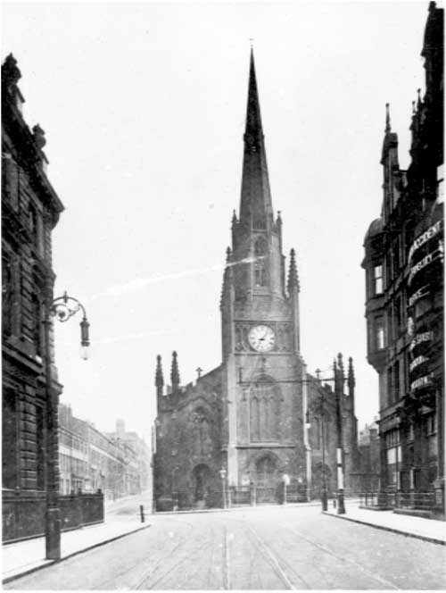

Undated, View of St Anne's Cathedral from Park Row with Cookridge Street on the left. Built in 1837-8 and designed by John Child on the formation of the Leeds Diocese in 1878 it acquired Cathedral Church of St Anne status. On the right is Peacock's Buildings home of the National Benefit Life and Property Assurance Co Ltd.
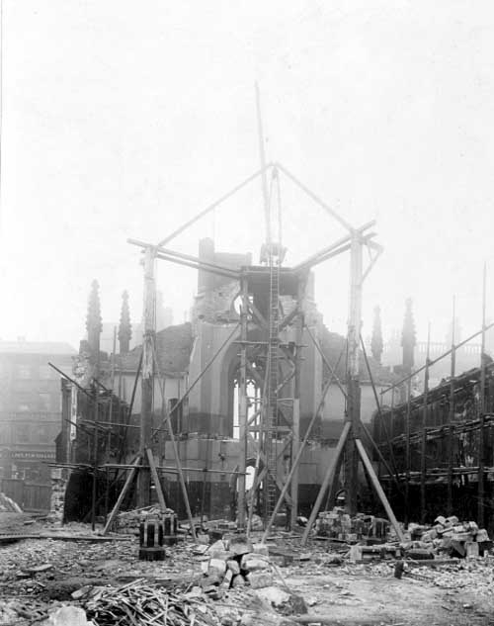

October 1904. View of crane supported by scaffolding during demolition of old cathedral. This is looking towards Guildford Street (Headrow). Number 2 premises of Peacock and Son Ltd, carpet and textile warehouse is on the left.
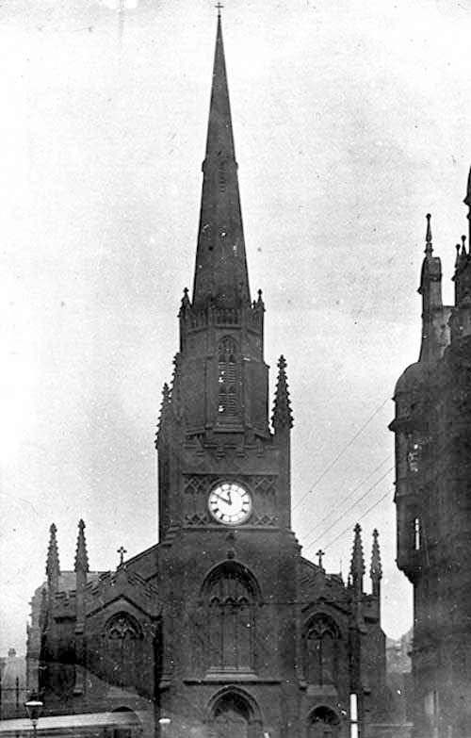

Undated, Photograph taken prior to demolition in November 1904. This was done for improvements to be carried out on the Headrow which at that time was called Guildford Street. A new cathedral was constructed on Cookridge Street

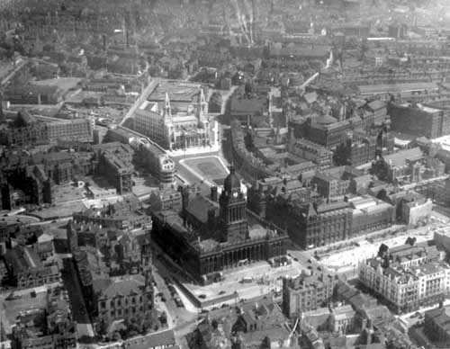

Forwards towards the center right edge is the new St Anne's Cathedral. The old one was situated right next door

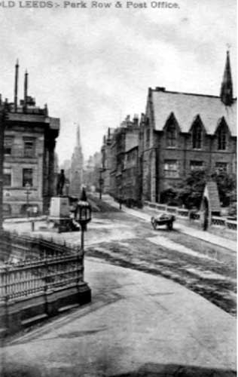

Undated, Postcard view of City Square and Park Row. To the left is the old Courthouse, built in 1813 it was later used as a post office when the courts were transferred to the new Town Hall. It was demolished in 1901. Park Row is in the centre, the spire of St Annes Cathedral, then on what was called Guildford Street (Headrow). Priestly Hall is on the left, with the Mill Hill chapel grounds. The statue at the junction with Park Row (left) is that of Sir Robert Peel. After his death in 1850, money was aised by public subscription to fund a memorial. Sculptor to fund a memorial sculptor William Behnes produced this bronze, the first large scale piece to be cast in one piece in Britain. It was the first Peel memorial to be erected, this was August 1852. It was later resited on Woodhouse Moor, at the corner of Hyde Park and Woodhouse Lane.
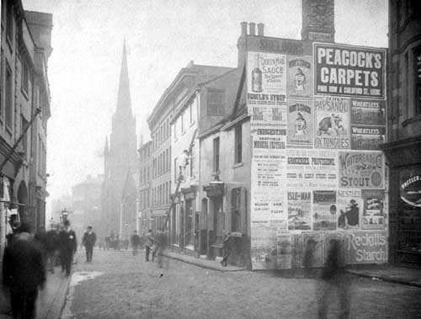

circa 1896. View looking along Guildford Street, a cobbled street, now part of the Headrow centre. The spire of St. Annes catholic cathedral can be seen. A horse and carriage and men up a ladder can be seen. A wall covered in advertisements is in the foreground.
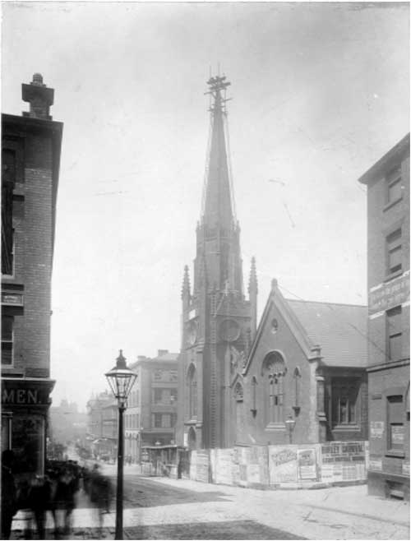

June 1904. Centre, St Annes Catholic Cathedral. Scaffolding in place, ready for removal of the steeple. All this block of property, including St Anne's was demolished to refurbish the new 'Headrow'. Built by local architect John Child, the church was opened in 1838. A poster in the fence announces that 'Burley Carnival will be held at Leeds football ground on June 25th 1904' On the left corner of Basinghall Street, a large crowd has gathered to watch the proceedings.

