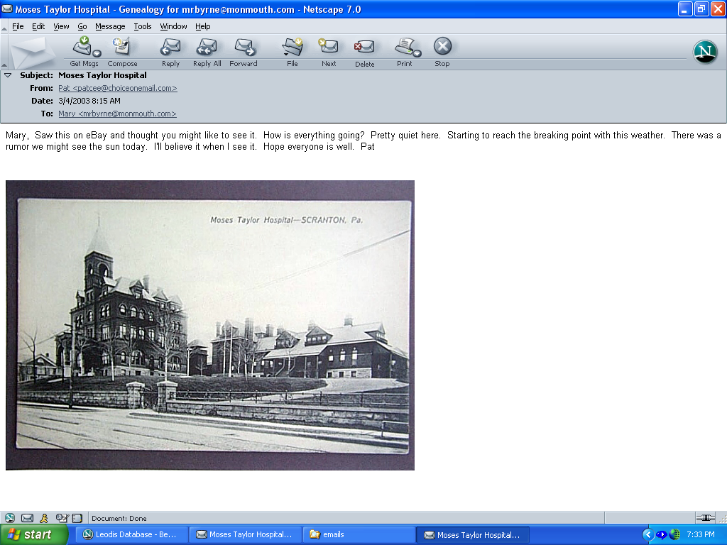
This is where my father died in 1941. See chapter 13 of my mother's "Frank of Tender Memory" book.
(Note by Mary Rooney Byrne)

