Could Mrs Sarah Ann Curtis be a relative of my great grandmother? Interesting indeed.
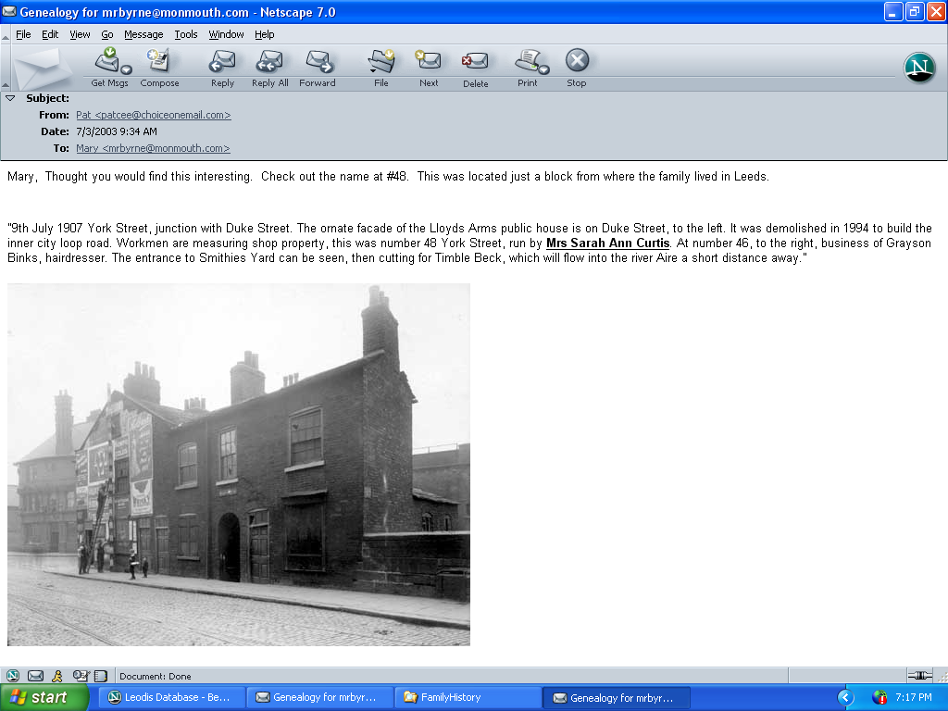
(Note by Mary Rooney Byrne)

