Lars Rooney’s
Western
Trip

August 10 – September, 1959

Alberta M. Rooney

Captions by Leo Rooney

Mon. August 10, 1959 This is the first day of our trip. We left when it was still dark and I was asleep.
We saw long tunnels in western Penna. They went right through the mountain. We saw trees, mountains, fields, cows and houses.
We went very far and traveled through Penna., Ohio and Indiana. We stayed at the Dausch’s apartment in South Bend.
Tuesday we visited the campus of Notre Dame. I have a Notre Dame shirt. I also met a little girl named Terry and showed her my jumping beans.

Wednesday the 12th. We started again on our way west. In Ill. we went through Chicago and I saw a totem pole in a park. We took some pictures on Lake Mich. We went through Wis. which was very beautiful. Minn. was also a lovely state. We found a place to stay in Albert Lea, Minn.

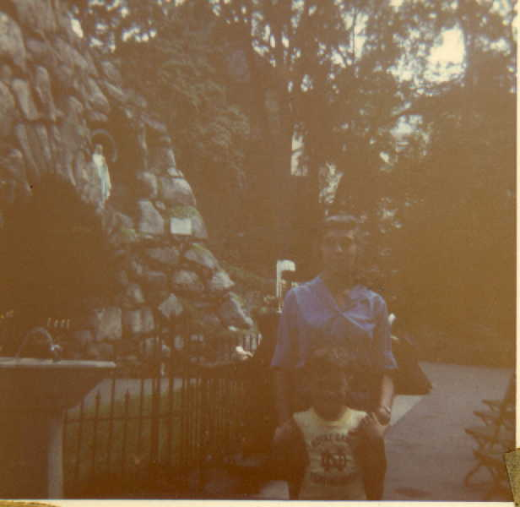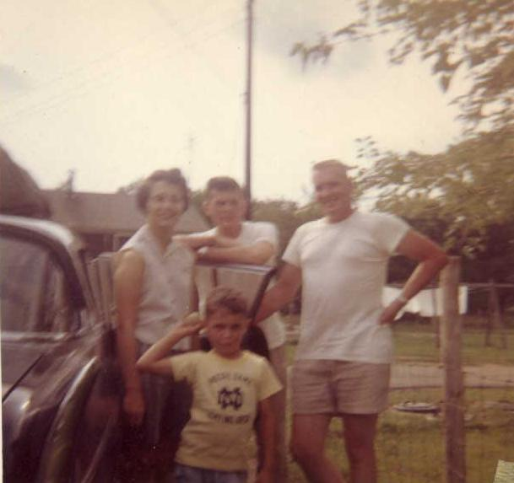
Replica of Lourdes Grotto with a few stones Carol, Vern, Lars & neighbor at Vet’s
from France Housing – Notre Dame

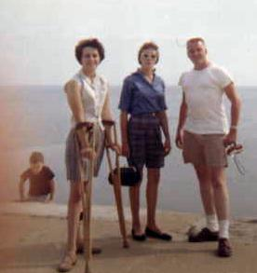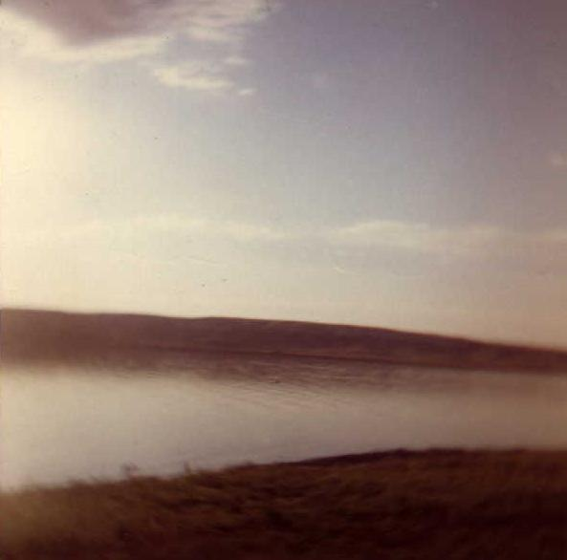
Lars, Carol, Al & Vern on Lake Missouri R. at Chamberlain, SD – Struck
Shore Drive – Lake Michigan, by brown hills
Chicago

Thurs., Aug. 13th. We left Minn. and traveled on to South Dakota which seemed quite poor. We stopped for the night at Chamberlain, S.D. We ate our supper in a nearby park on the Mo. river where I lost my ball. We saw some Indians in Chamberlain.

Fri. Aug. 14th. We were on our way to the Badlands.
We stopped at Kadoka, S.D. and saw prairie dogs and bought some souvenirs. The prairie dogs look like beasts.
We stopped several times in the badlands. They were colorful hills. I had my picture taken in a little cave in one of these hills. At one stop there was a plank bridge over a deep hole, the bridge had no rails. I decided to walk backwards over this bridge with my eyes closed until Daddy caught me.
I saw a big dinosaur at the side of the road as we passed Wall, S.D. We saw another dinosaur on a hill in Rapid City.
In Rapid City we visited the Souix Indian Museum.

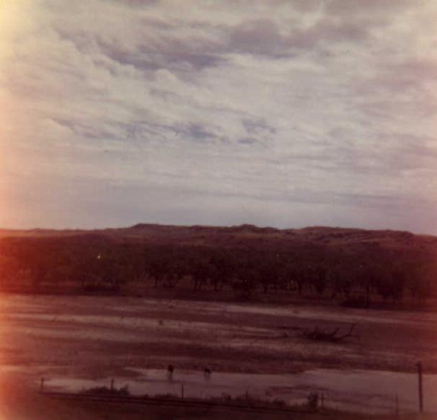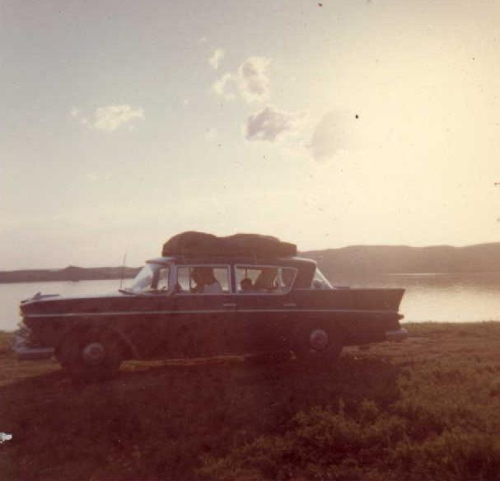
Cattle browsing in East Chayenne R., S.D. Picnic site on dammed (read closely)
Missouri R. – Chamberlain, S.D.

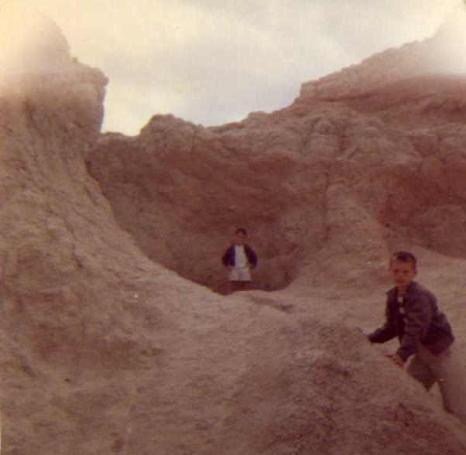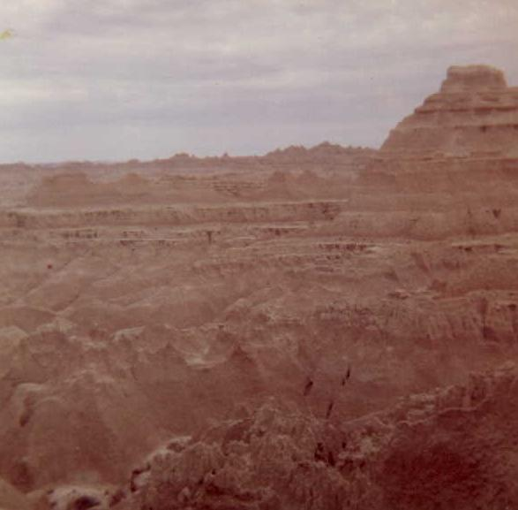
Lars in eroded niche of the Badlands, S.D. Badlands, S.D.

We ate lunch and headed for the Black Hills. We went through a tunnel cut out of solid rock to get to Mt. Rushmore. At Mr. Rushmore we saw Pres. Wash., Pres. T. Jefferson, Pres. T. Roosevelt and Pres. Lincoln carved in stone. I looked through a telescope and could see Pres. Roosevelt’s glasses. We saw some Indians here.
We traveled through the Black Hills until we came to New Castle Wyo. We went swimming in the Motel swimming pool. The water was heated but the air was cold.
We had dinner at a restaurant where they gave me a space man mask and some life savers.

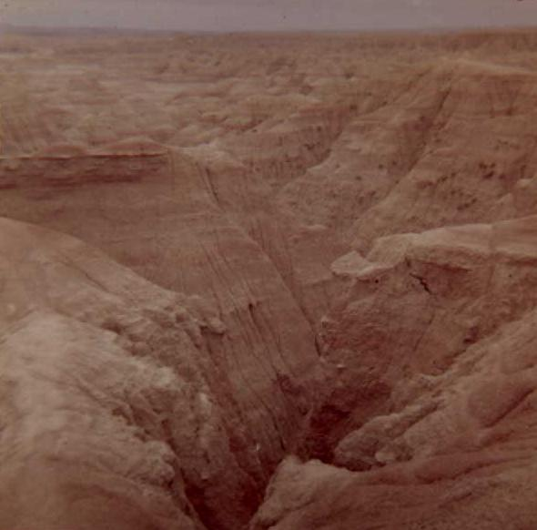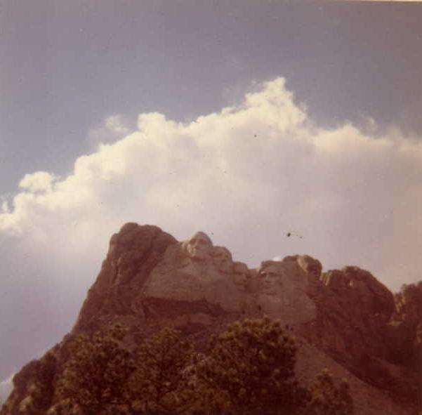
Badlands, S.D. Mt. Rushmore Memorial, S.D.
Reached after a gauntlet of tourist traps
Forest of “Mission 66” signs

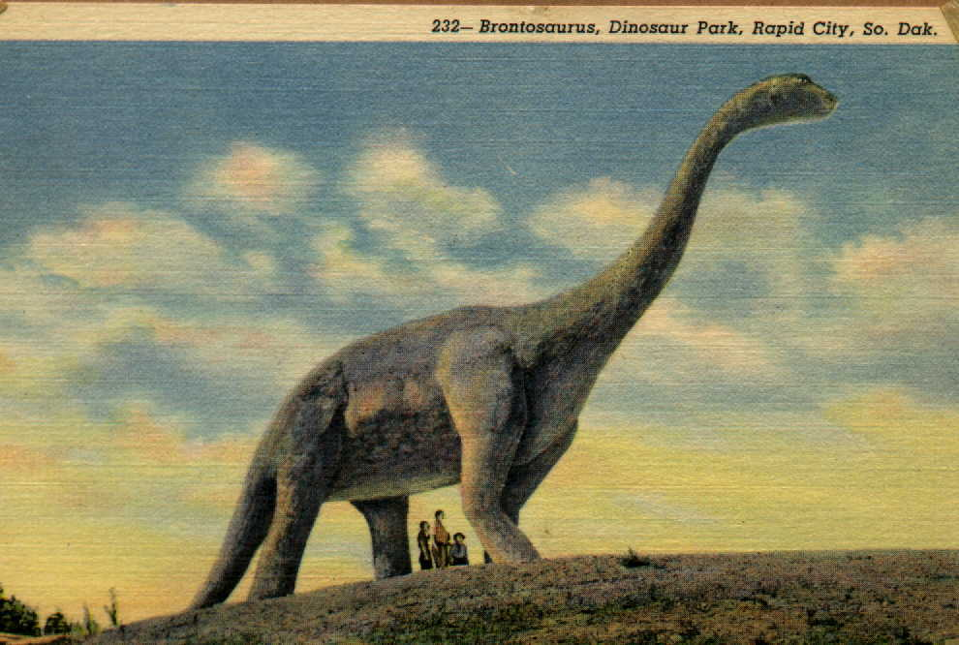

Sat. Aug. 15
We could see Devil’s Tower from the car in the distance on our way to Yellowstone. The country around us is very dry because of no snow in the past winter and no rain in summer.
On the road we saw a truck carrying a portable drill for drilling oil in Wyo.
We entered the Big Horn Mts. about 2 o’clock. The road was narrow and winding and we climbed up and up. We stopped and could see the valley for miles around. We could also see the road we had just driven over. We were 8900 feet high. In the middle of the mt. range we stopped at a stream and looked for gold. We only found some pretty stones.
When we got out of the Big Horn’s we stopped and Uncle Vern and I bought Cow Boy hats.
We stopped for the night at Cody Wyo. After eating we went to a rodeo. It was nice but the wind was so strong we got very cold.
A little boy named Martin had a chipmunk at the motor court. I liked to go over to see him.

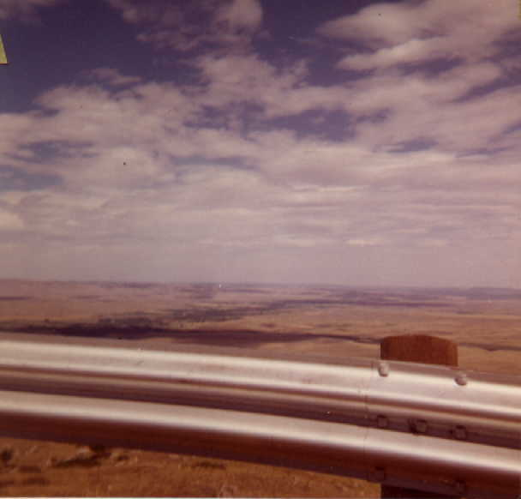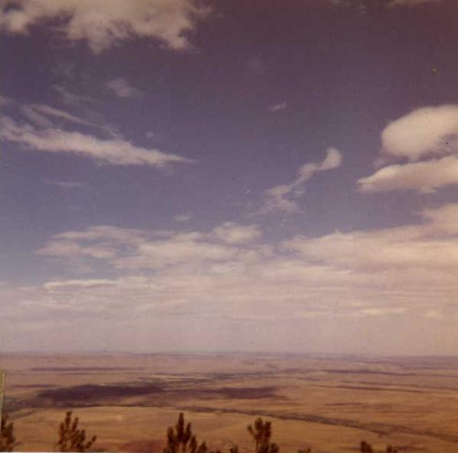

Views seen ascending (abruptly) eastern slopes of Big Horn Mountains, Wyoming.

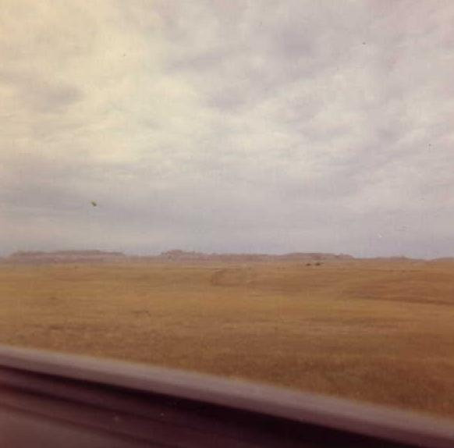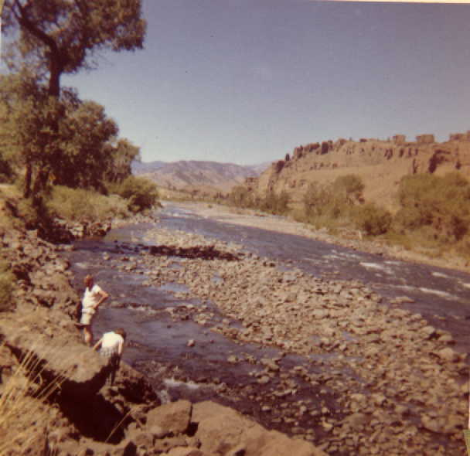
Two latter day Wyoming prospectors

Aug. 16, Sunday

Today is mommy and daddy’s wedding anniversary.

We visited the Bill Cody Museum and the Western Art Museum in Cody. The museums were right across the street from our motor court.

Now we are heading toward Yellowstone National Park.

We came up out of Cody through the Shoshone Canyon which was very steep. We drove along the Buffalo Bill Dam through rock tunnels and overhanging cliffs. As we came to a river I guessed it was the Shoshane.

When we passed the Eastern Gate to the Park we saw bear and bear cubs walking along the road. We took some pictures of them.

We stayed at the Canyon Junction Motor Court.

We saw more bear when we went to cook our lunch on the banks of the Yellowstone River. The river ran very fast and had many rapids. It was a beautiful green color. Afterwards we drove on and saw many waterfalls and high mountains. We took some pictures. Mommy & daddy took a picture in front of Undine Falls. Then we saw the best thing of all, the Moose. We went up close and took a picture of them. When mommy and I saw a moose look at us we ran away and we fell down! Right after that we saw some elk, mothers, fathers and babies. We took a picture of them too. Oh, yes, we took my picture with a chipmunk, high above the Yellowstone river.)

We saw Obsidian Cliff and climbed it. We brought back some obsidian samples with us. Daddy and I played a trick on mommy. We bought a piece of obsidian at the General Store and told mommy we found it in the rocks. It was a good joke because the piece we bought was smooth not sharp like the pieces we found.

We saw Monmouth Springs where they had terraces and springs. The terraces were covered with travertine and we got a piece of it. It was very brittle and white. Daddy took a picture of mommy and me in front of a big rock near the terraces.

We went out to cook steak for supper. While we were waiting for it to cook we saw a bear walk right past us down the middle of the street in the camping area. Later we saw a larger black bear come out of the woods not six feet from us and go eat garbage out of the garbage can right in front of us. Boy, were we scared.

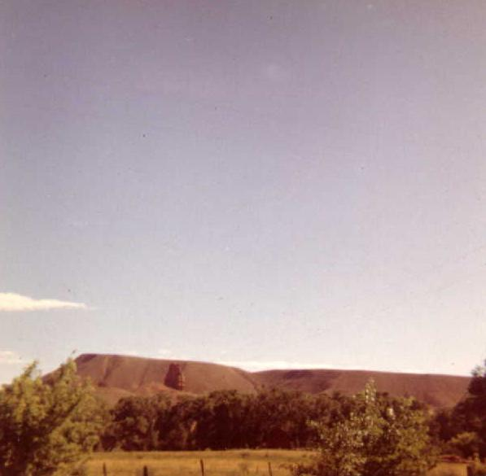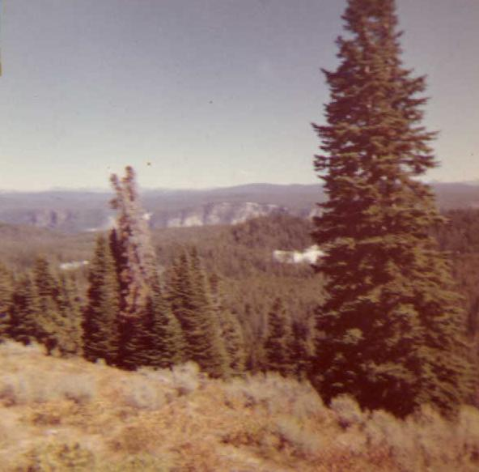
Red Rock seen after descending Big Horns in Unidentified, but nice
Wyoming

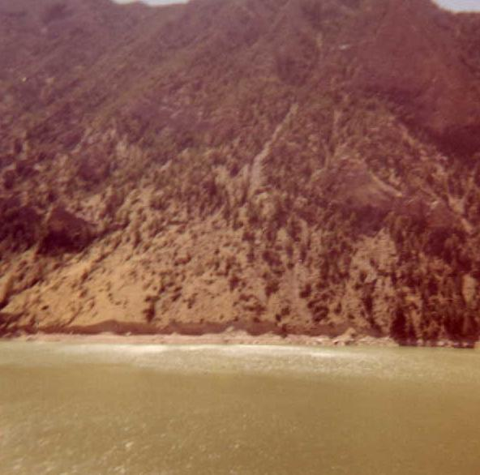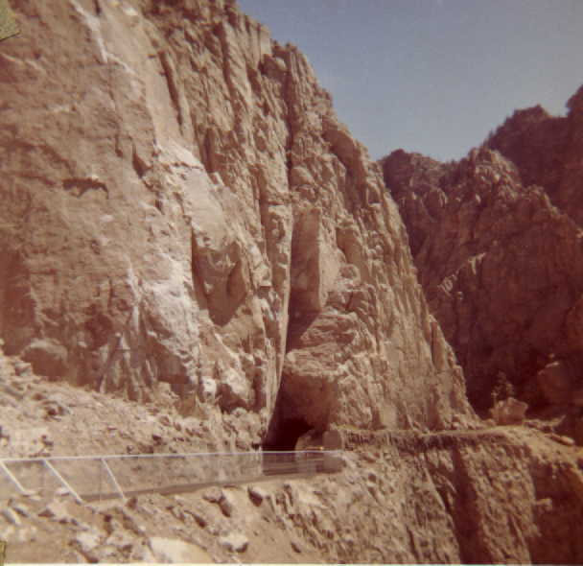
Emerald green reservoir of Buffalo Bill Road to Y.N.P. afterleaving Cody. Buffalo
Dam, Wyo. Bill Dam – Narrow torturous road

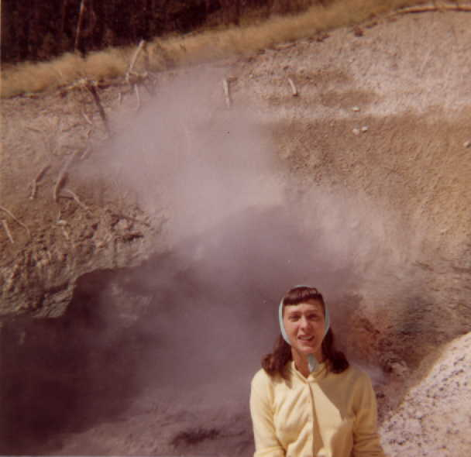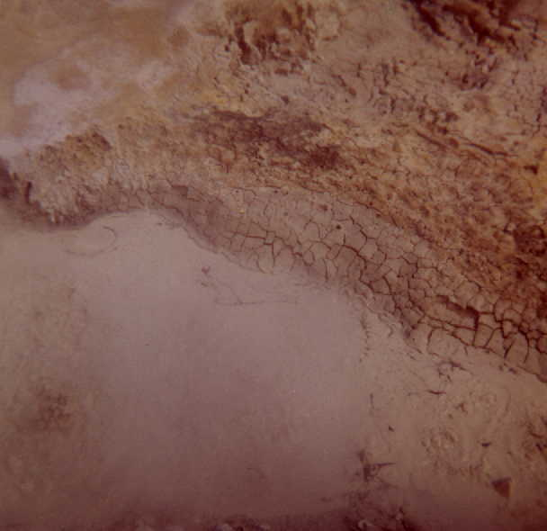
Witches Caldron, Y.N.P. – Attendant on duty Bubbling mud – sulpherous funes

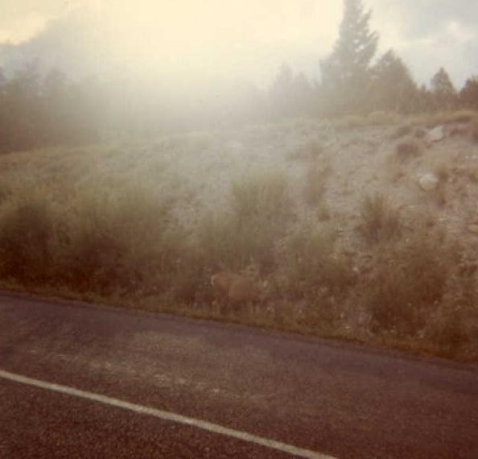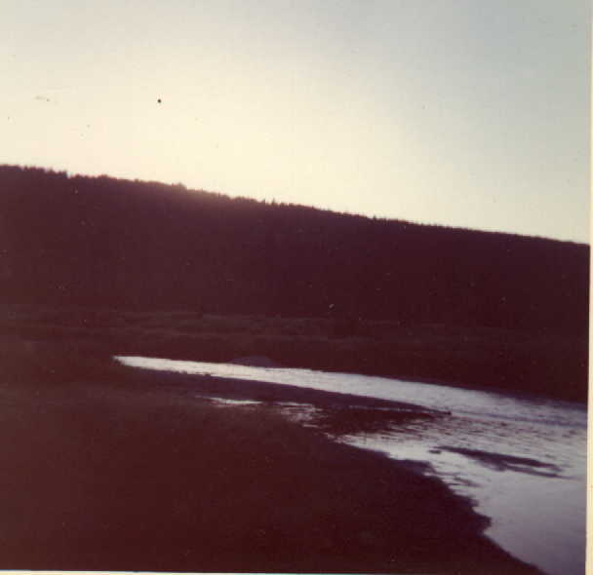
Mule deer – YNP Moose -- YNP

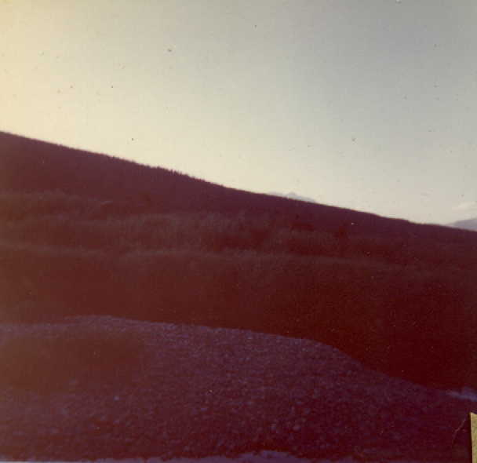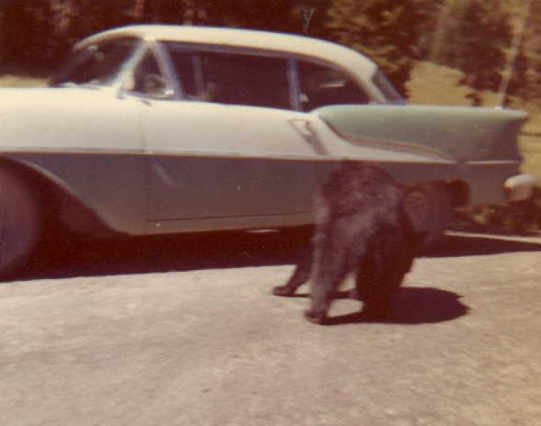
Moose – Y.N.P Welcoming committee – Y.N.P

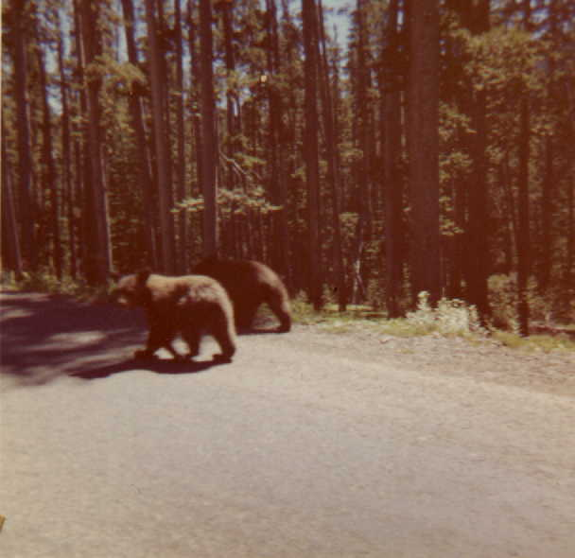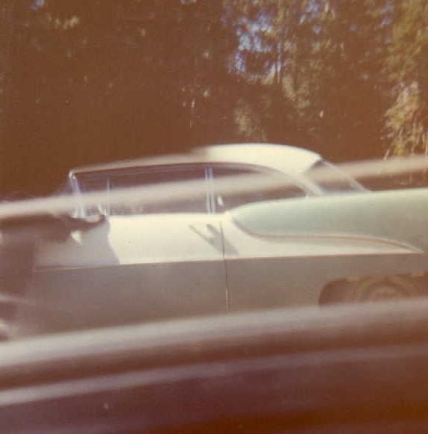
Park owners Hungry bar

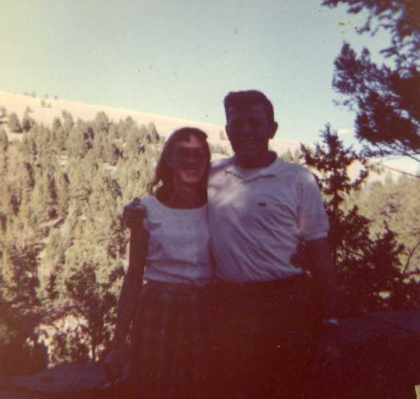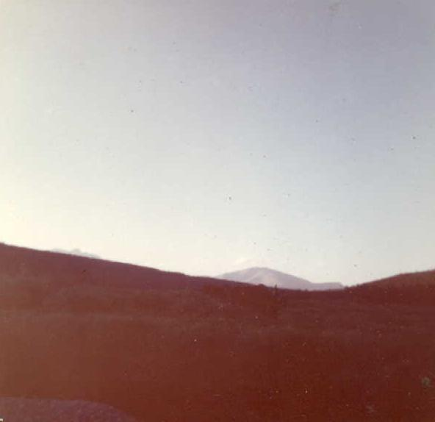
Seventh wedding anniversary Moose or possibly elk

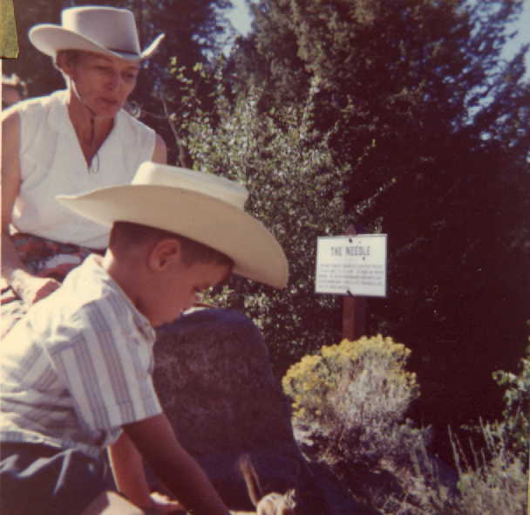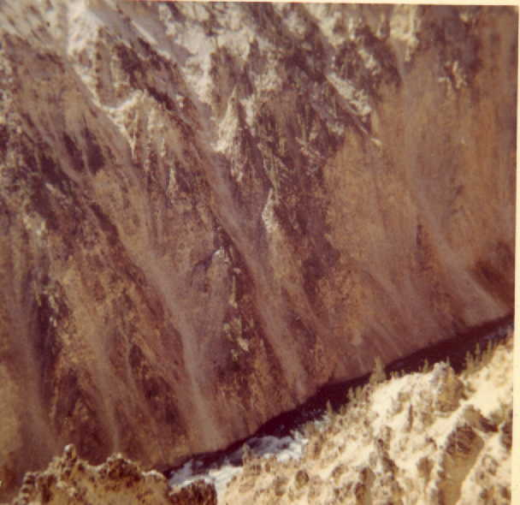
Lars & friend Grand Canyon of the Yellowstone

Monday, Aug.17 The first thing we saw today was the Grand Canyon of the Yellowstone. Then we saw the upper and lower falls.
We stopped at the caldrons (sulfa devils) and saw the bubbling mud. That sure smelled bad. I got a little sprayed and had to wear daddy’s sun glasses. We got some pictures of these. We just made it in time to geyser hill where we saw Old Faithful go off. It was a high spray of hot water and looked very nice. I liked it best of all. We took a tour with a guide all around geyser hill and saw the boiling hot water. Some of the water in the holes could be seen. It was a nice green color. We drove around and saw more of the same. On our way home we saw a mule deer, and took a picture of it. Later we saw bunnies across from the Mamouth Springs hospital.
We also saw Lake Isa, which is on the Continental Divide. It sends water down to the Pacific as well as the Atlantic Ocean. It had Lily Pads floating in it.
At night while I was sleeping there was an earthquake. The motel was shaking and so were the beds. People started to leave right away. We stayed until the next morning when I felt the quake. The road to the Grand Tetons was closed so we went to Great Falls Montana to visit Aunt Carol’s Uncle and Aunt. We saw some Buffalo in a pen and took pictures. I took a picture with the baby Buffalo. Then we traveled through many miles of farmland where they did dry farming. It made many pretty patterns.

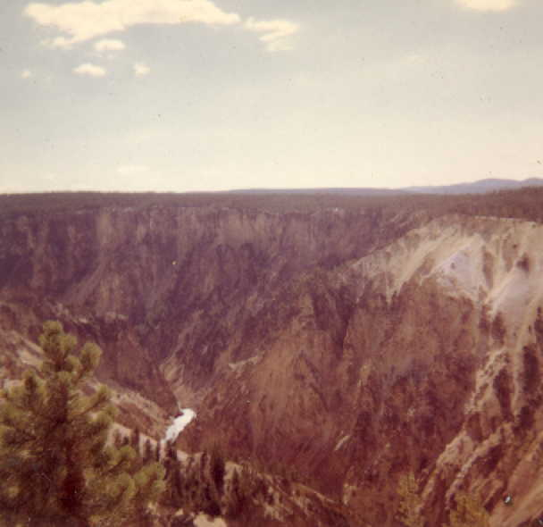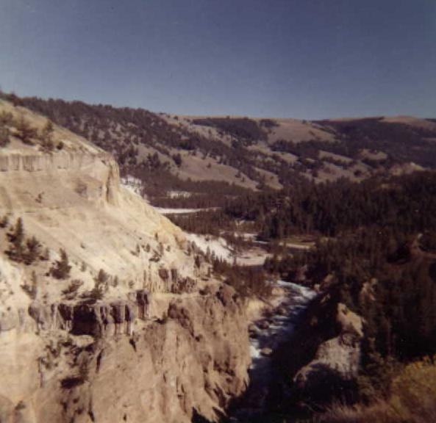
Grand Canyon of the Yellowstone Yellowstone River

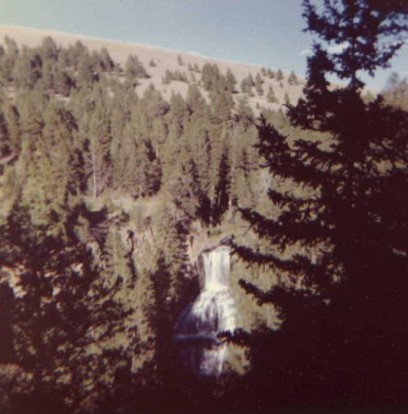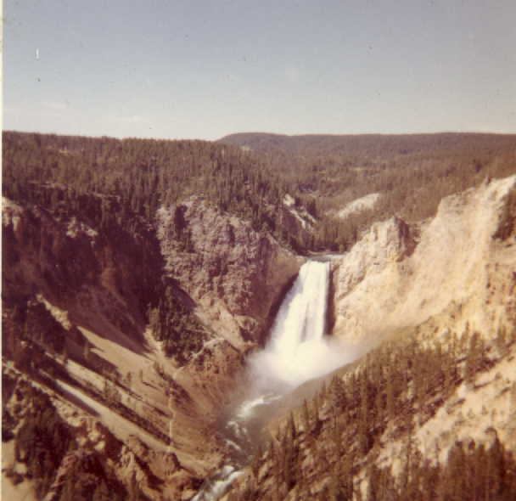
Falls on Yellowstone

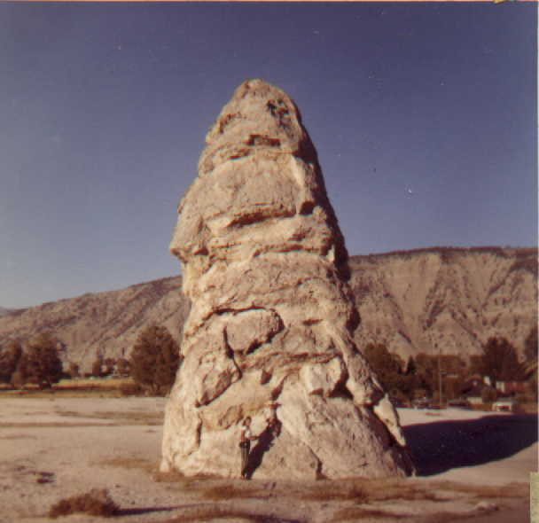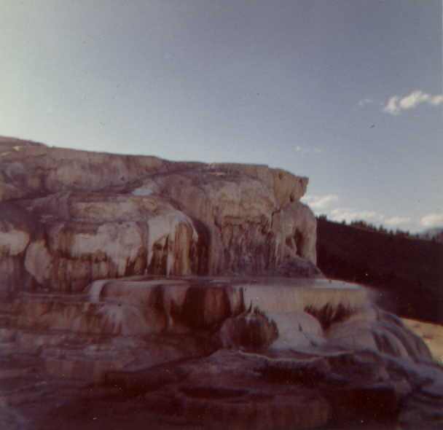
Mammoth Springs – Y.N.P.

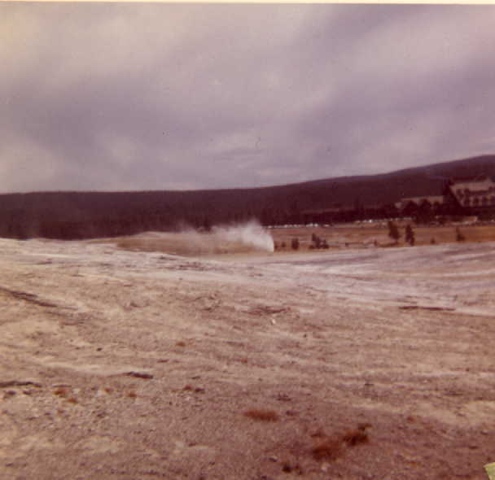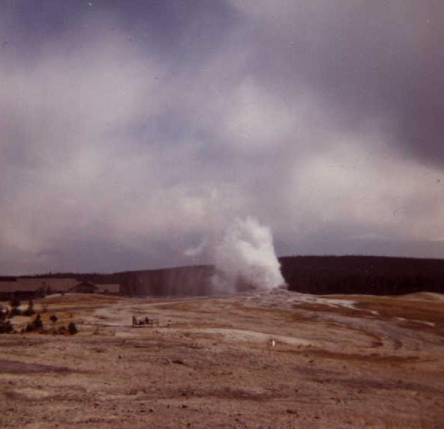
Geyser basin Shot by Lars of Old Faithful
as seen from geyser basin.

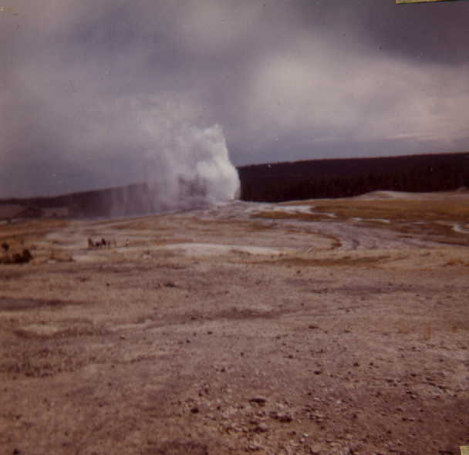
Old Faithful from Geyser Basin Surf on Yellowstone Lake

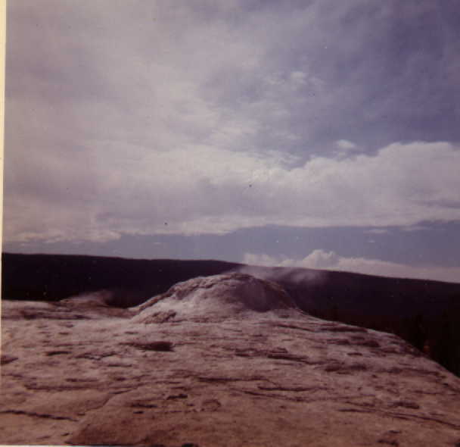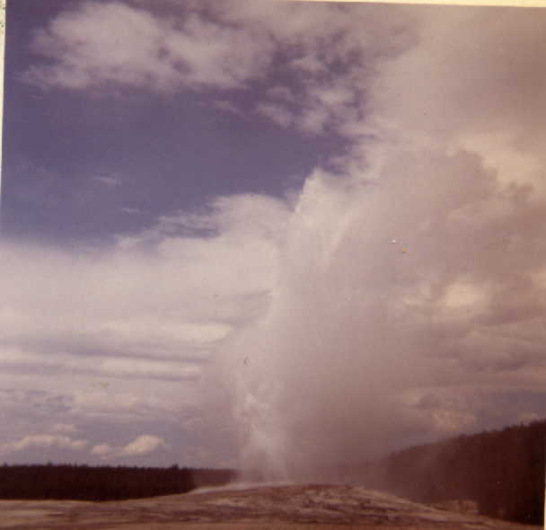
Geyser Basin

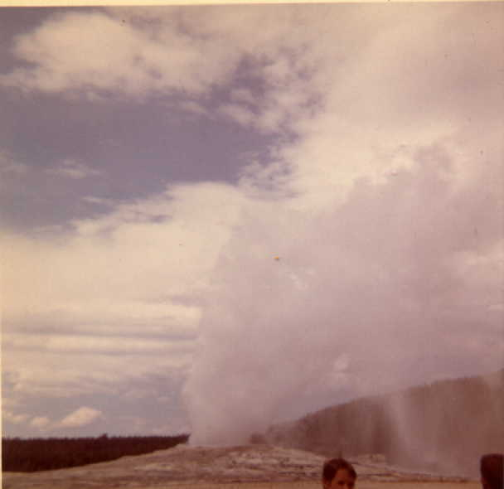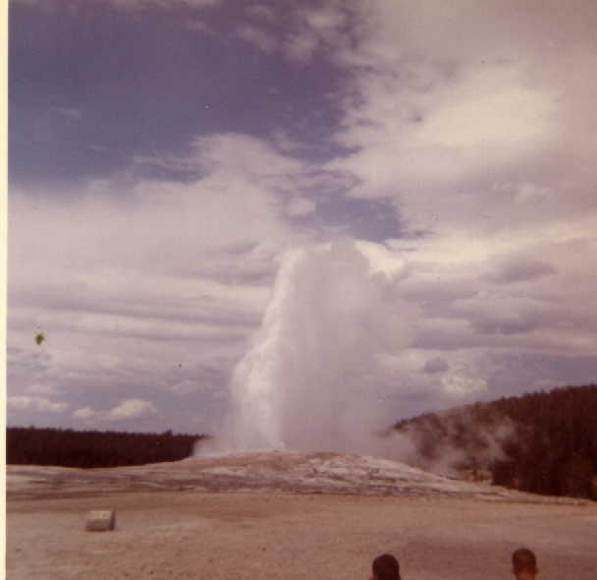
Old Faithful on the Inn side

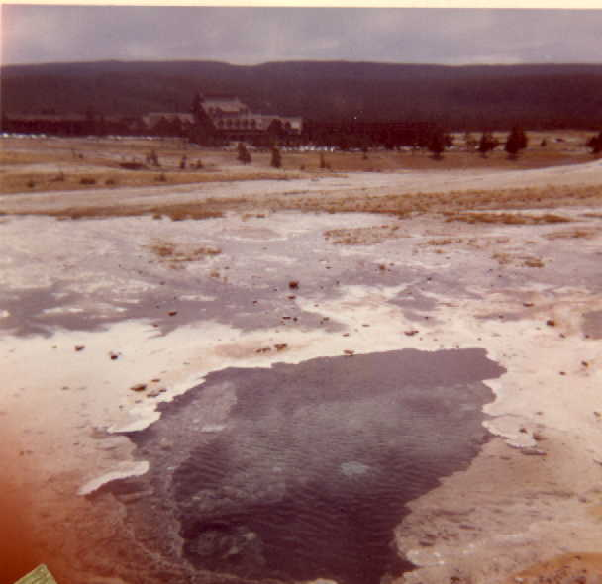
Deep clear pool in geyser basin

Aug. 19. Wednesday
We are riding across Montana after we had stopped for the night at Great Falls, where Aunt Carol’s aunt and uncle lived. We crossed Idaho into the state of Washington. The ground was dry on this side of the mountains in Wash. We stopped for the night in Spokane.

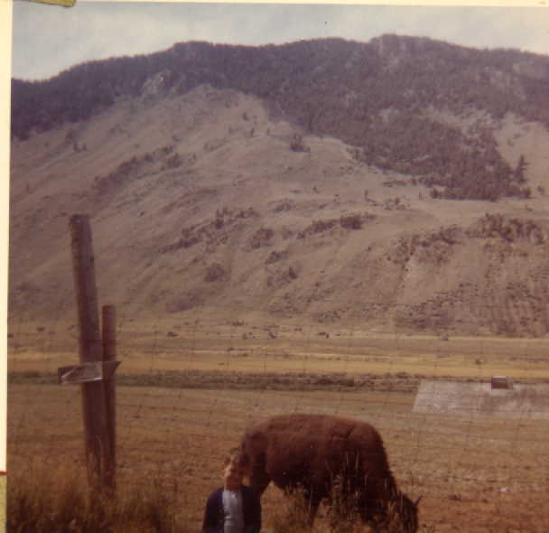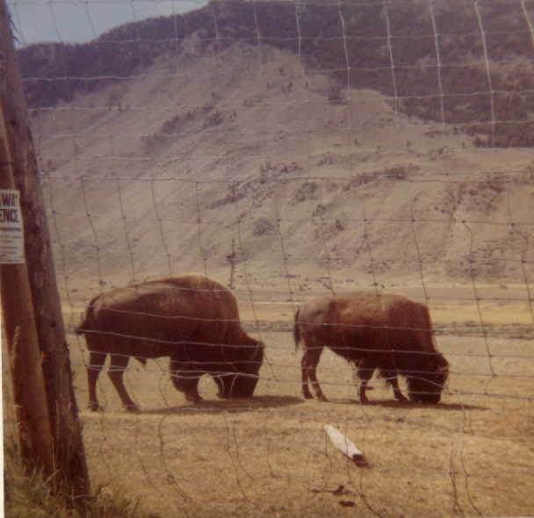
“I only want to get near the baby one”
In Montana on way to Great Falls.

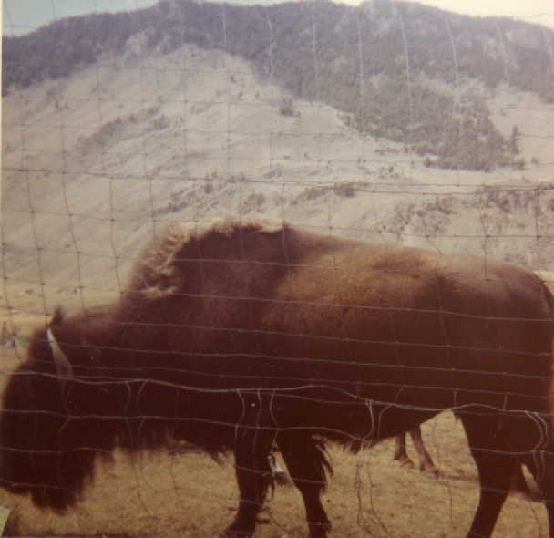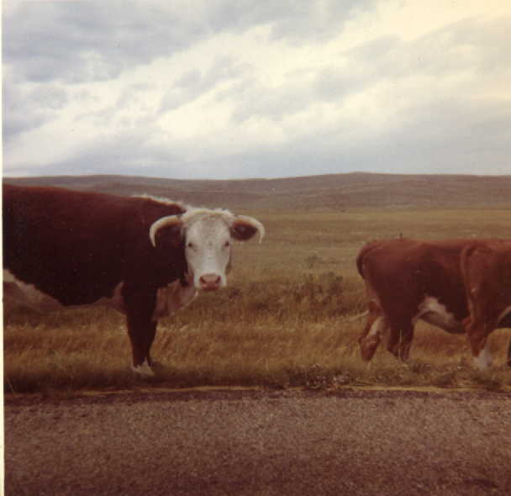
“Old Shaggy” – near YNP Cattle grazing along highway
on way to the Falls – Signs offering
reward for rustlers.

Aug. 20. Thursday
We drove until we came to the town of Pasco where the Snake River joined the Columbia. We followed the Columbia all the way to Portland. On the way we stopped at Bonneville Dam which is in the Columbia gorge. I thought it would be nice to catch the fish. We saw the fish ladder at Bonneville and saw fish going through the counter. We also saw the hatcheries. In the pond we saw a 4-ft. sturgeon and some large rainbow trout. The sturgeon was a giant fish I thought. After that we drove to Aunt Johanna’s and Uncle Leo’s in Longview. We had a wonderful time here. I made some friends and played on the playground nearby. We went for walks around the lake and into town. I like meeting Aunt Johanna and Uncle Leo best of all.

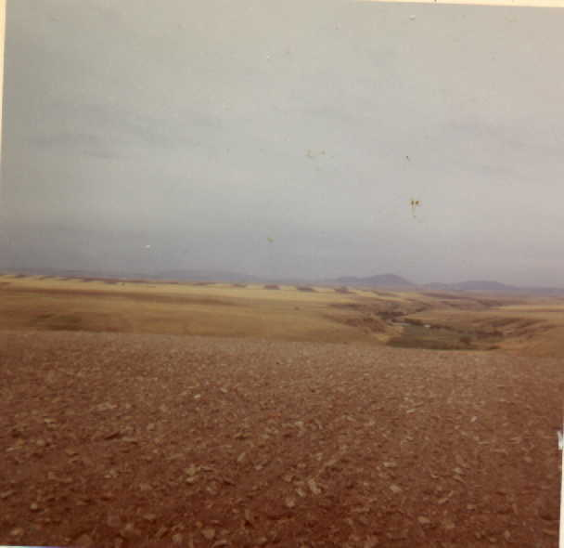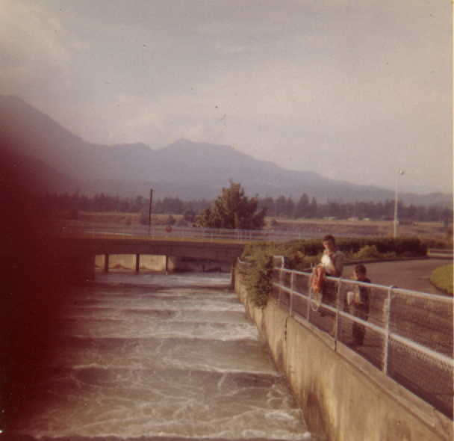
Dry farming near Great Falls, Mont. Salmon ladder – Bonneville Dam
Columbia Gorge, Ore.

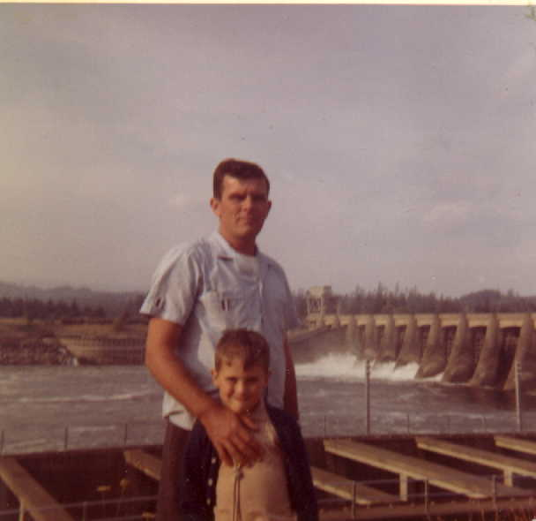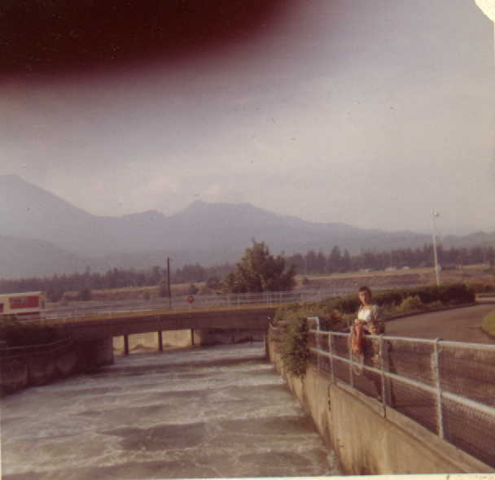
Fish ladder forefront – power site in back Salmon ladder – Bonneville Dam
Bonneville

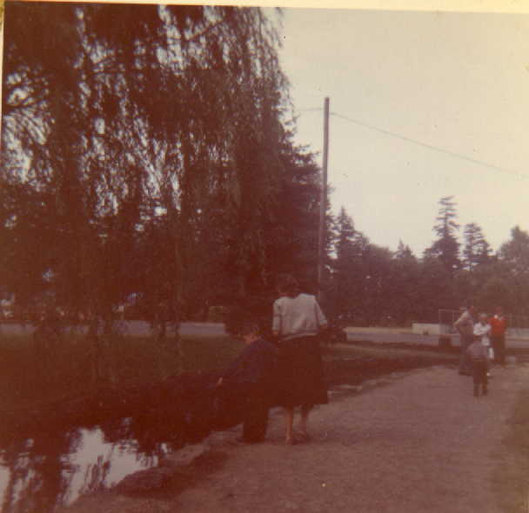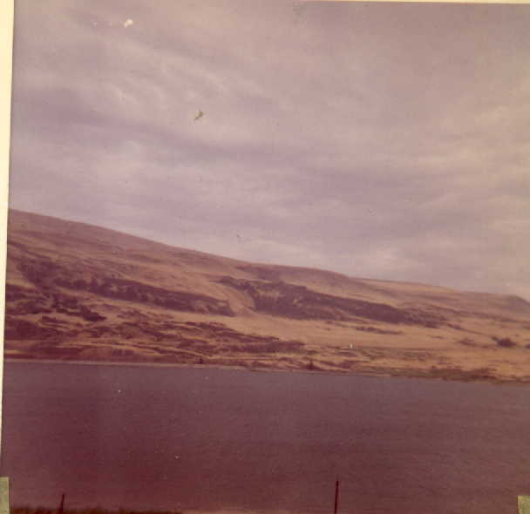
Fish hatchery at Bonneville Dam -- Columbia River from Oregon side –
Lars pointing at four foot sturgeon east of the Gorge

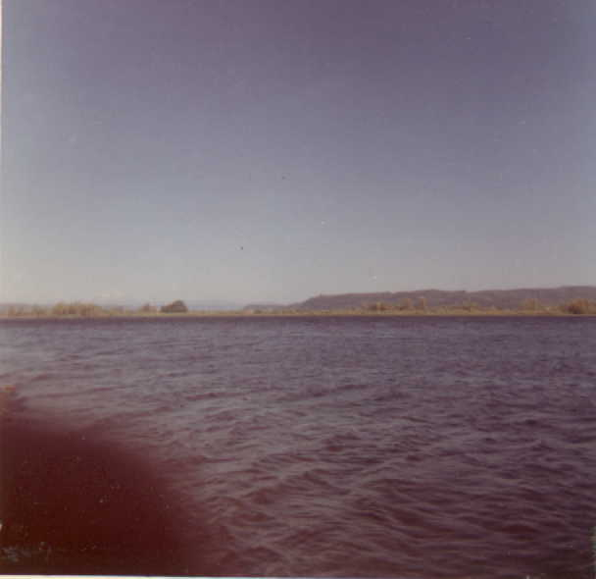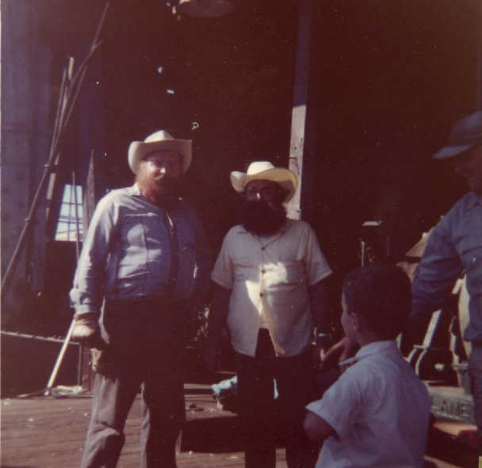
Columbia where it widens near its mouth. Celebrants of Oregon’s centennial, & admirer

Sunday – August 23
We visited the Docks in Longview. We saw three ships being loaded with lumber. Two of the ships were from Japan. We saw men using a machine to take wheat out of a barge to store it in the grain elevator. I found some barley and made Rooney brau bock beer when we got back.

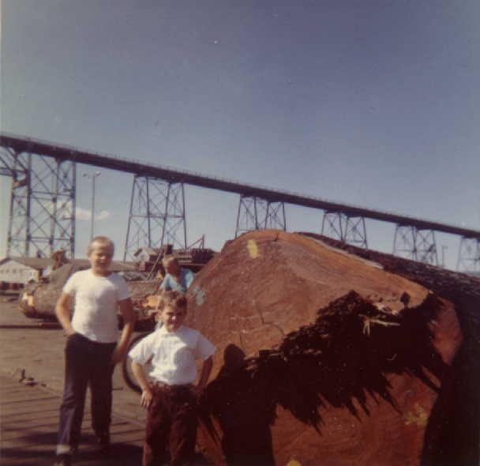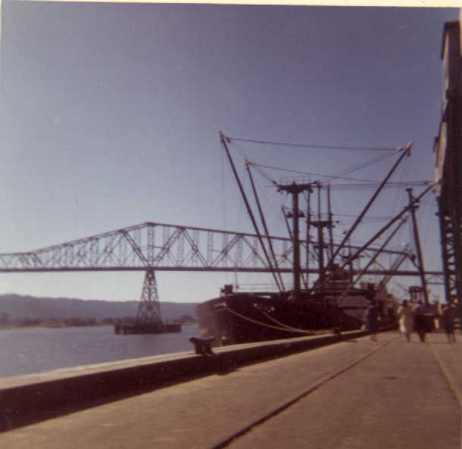
Longview docks

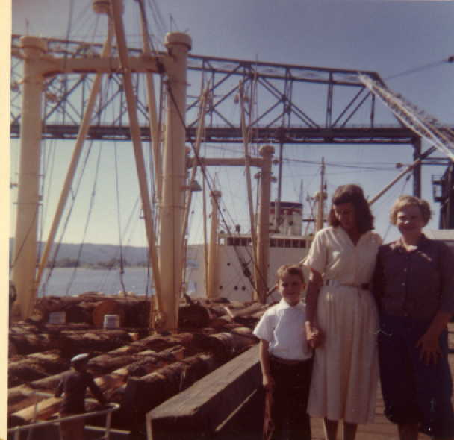 | 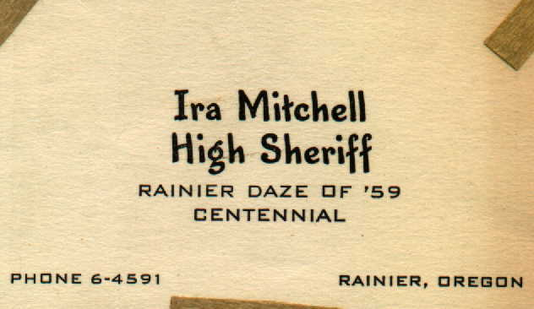
The Dalles, a city in Oregon, derives its
name from the French word for
“flagstones.”

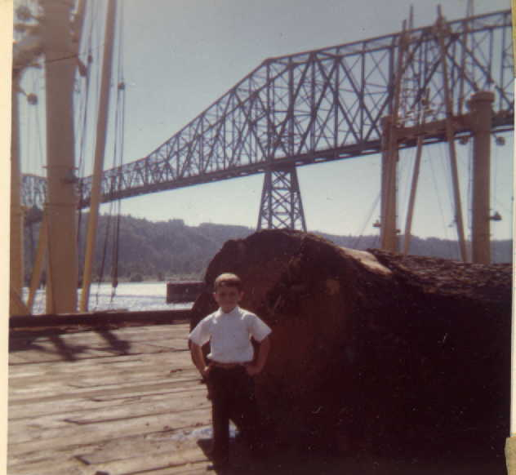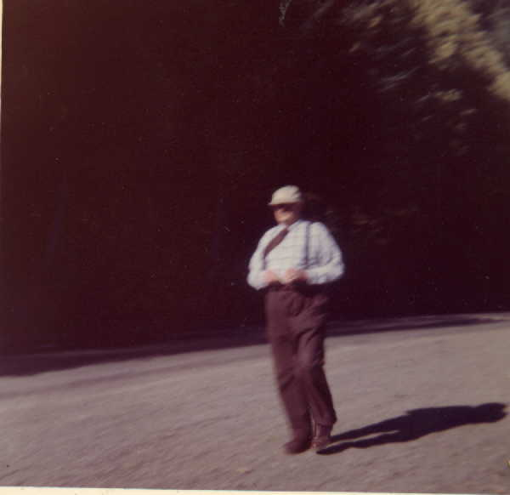
Longview bridge from docks Uncle Leo

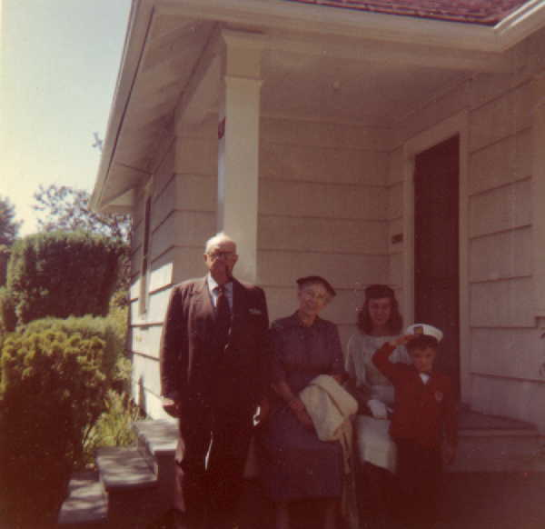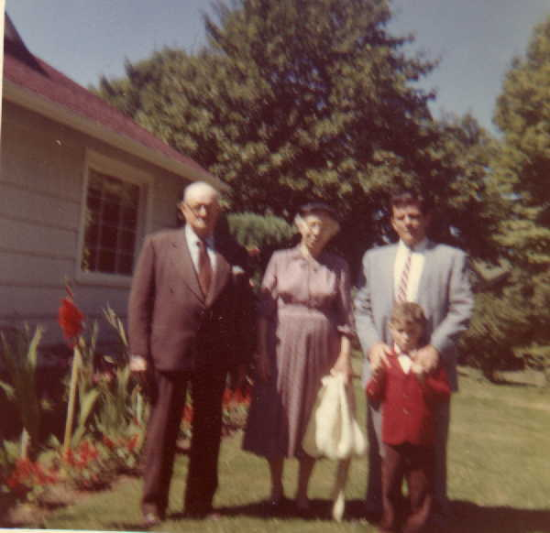
Home of Aunt Johanna & Uncle Leo – Longview, Wash

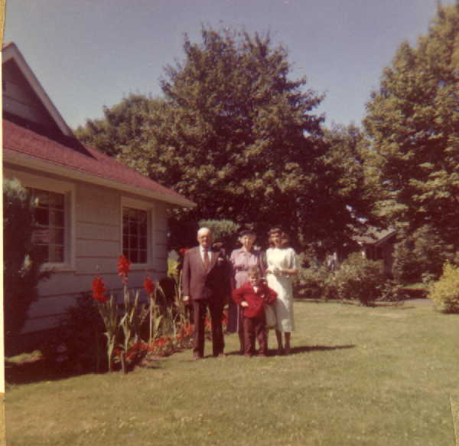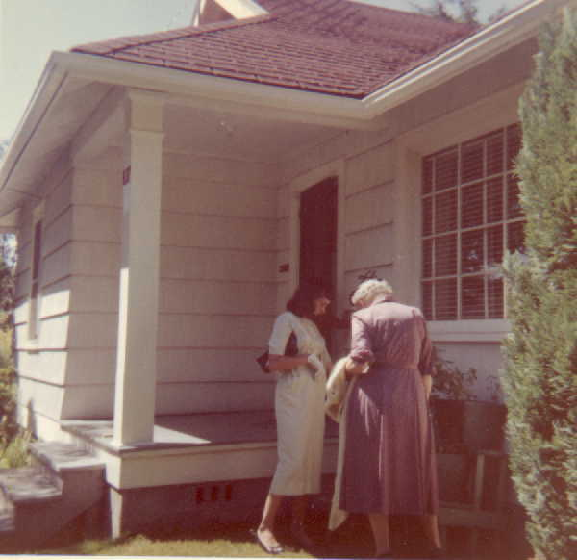

Longview, Wash.

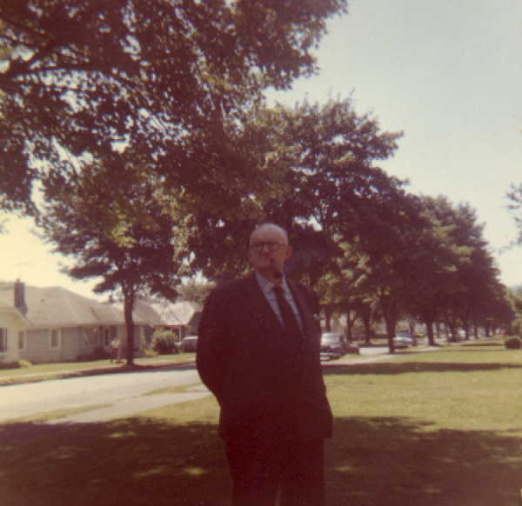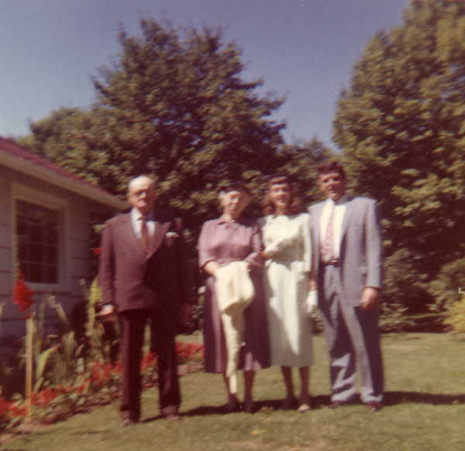

Monday – Aug 24.
Mommy and Daddy went to get our plane tickets while I played. In the afternoon Aunt Johanna took me and the Smith children to the playground while mommy, daddy and Uncle Leo went to visit a lumber mill. I got a piece of wood from the mill.

Tuesday – Aug 25
We got up at 5 o’clock in the morning. The Martin’s were going to take us to the Portland Airport then they were going to the Portland Exposition while we flew to San Fransisco. The plane ride was very, very exciting. The houses looked very tiny down below and the road looked like ribbons. I ate plums and drank some milk on the plane.

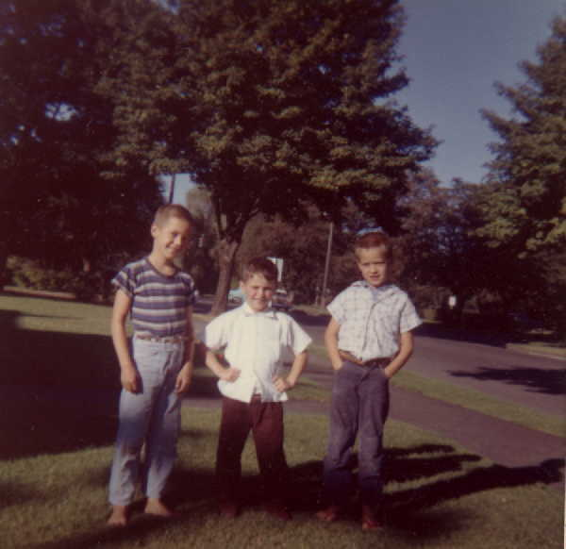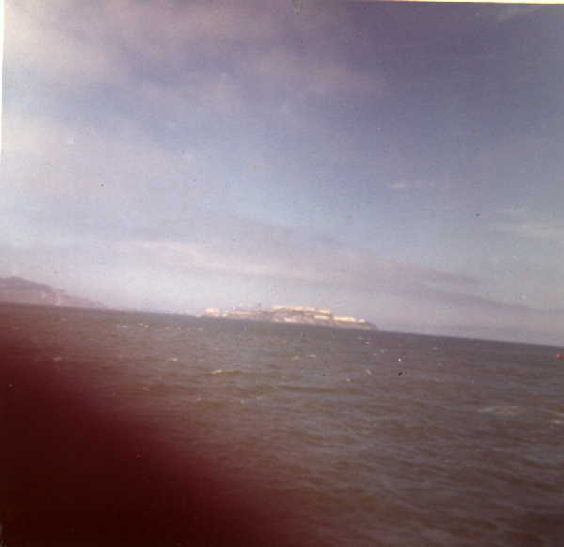
Lars & friends in Longview ALCATRAZ – 1 mile

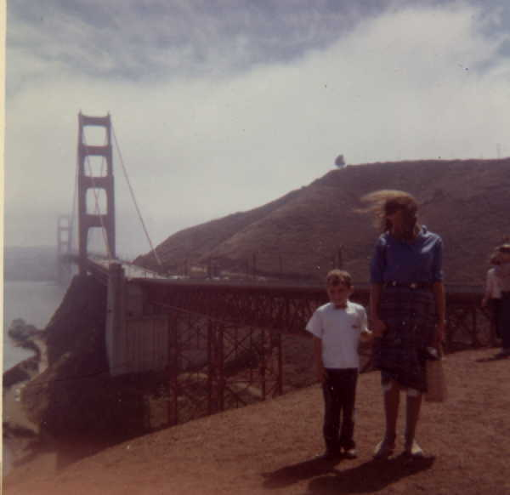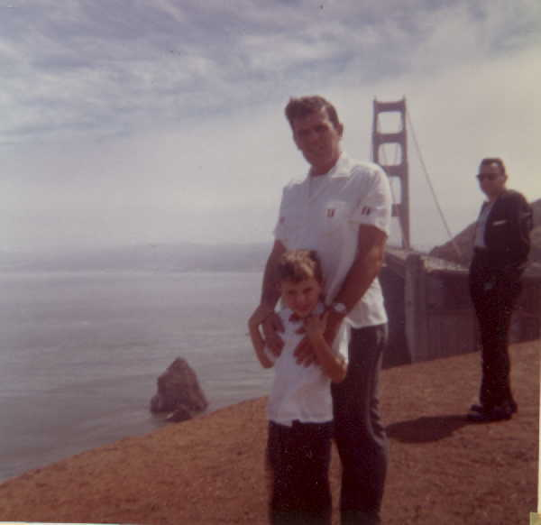
Northern side of Golden Gate Bridge On way to Muir Woods

We landed first at Oakland and then flew across the bay to Frisco. We found our hotel and ate the sandwiches Aunt Johanna had made. We had to run to find a bus that would take us on a tour through Muir Woods. The bus took us past the Hall of Justice and stopped so that we could see Alcatraz, where they keep the bad men on an island. We crossed the Golden Gate Bridge and stopped again to take pictures. We traveled a winding road that was exciting until we reached the redwoods.. We saw many tall and very old trees. There were openings like caves in many of them. One was a wishing tree and I made a wish in it. We looked inside a few, that was fun. We bought some souvenirs here. One of my souvenirs was a bear made out of the hardest part of the tree. The hardest part was called a burl and was caused by the tree trying to repair itself after it had been damaged.

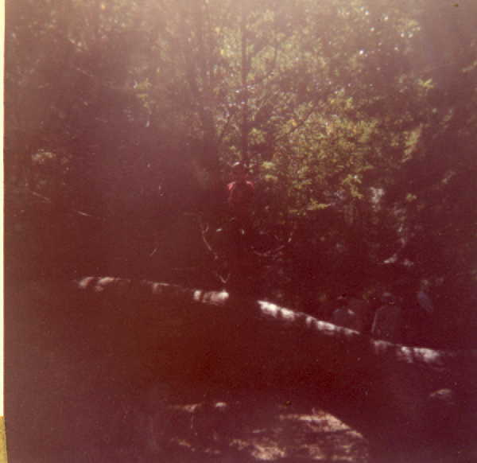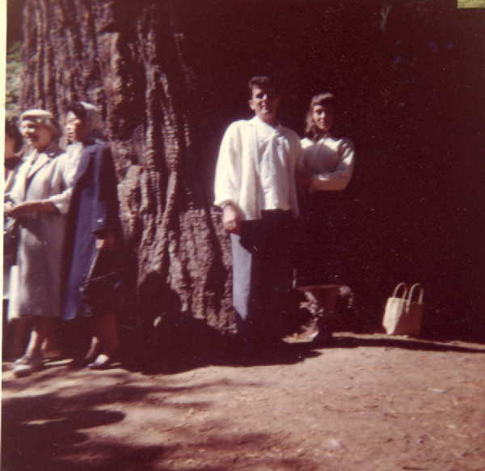
Muir Woods north of San Francisco – Redwood forest

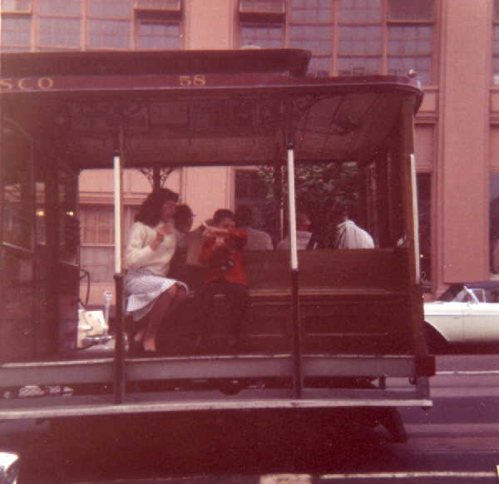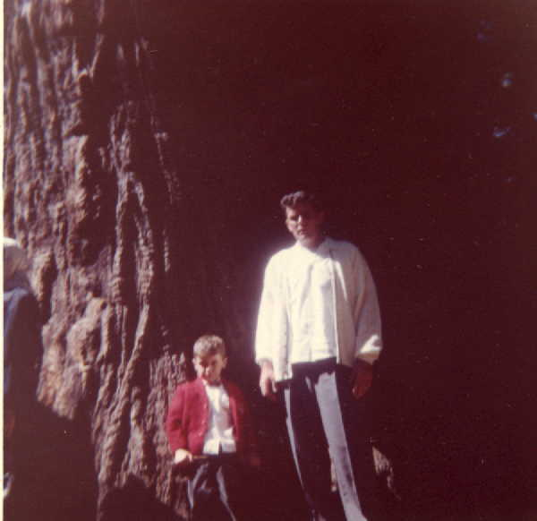
San Francisco cablecar

For dinner we went to Fisherman’s wharf where mommy and daddy had abalone steak and I had salmon to eat. I bought my binoculars here. Then we rode back to the hotel on the cable car. That was fun.

Wed. Aug. 26
After we ate breakfast we walked through Chinatown and I bought my pop gun. We rode the cable car again and then the bus to go back to the hotel. We had to get ready to take another plane to Los Angeles. When I was on the plane a while the stewardess gave me a Junior Airman’s flying pin. I showed her the other one I had. That was a little different, than what I got when I was on the other plane. The plane ride was nice because we flew right through the clouds and then were on top of them. They looked like snow.

Aunt Beth, Uncle John, Jim, Barbara and Joanie met us at the airport and took us to Camarillo. It was fun to play with children again.

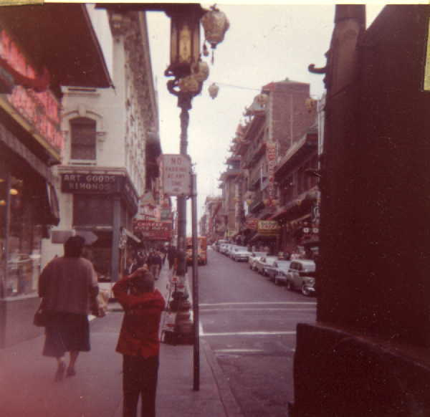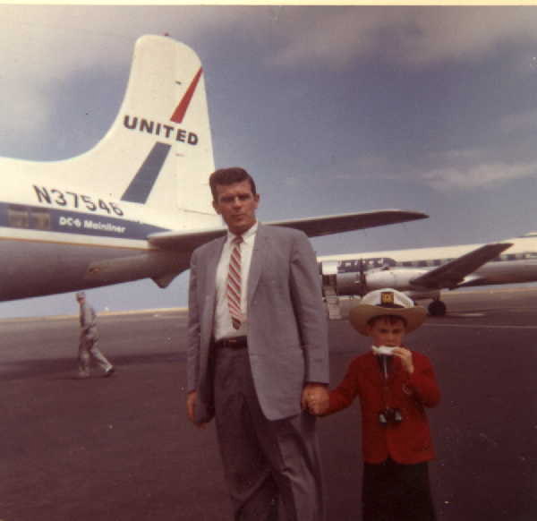
Chinatown, San Francisco San Francisco airport on way to
Lars shooting at carping parents. Los Angeles – Two hats are better
than one.

Thur. Aug 27
We started off for a picnic and a swim in the Pacific. On the way we stopped and visited Santa Barbara Mission. I liked the stone things and I rang the bells. Mommy stopped me from ringing the bells again.

In Carpenteria we had our picnic and the children went for a swim. It was a little cold. I found some stones, shells and seaweed for mommy.

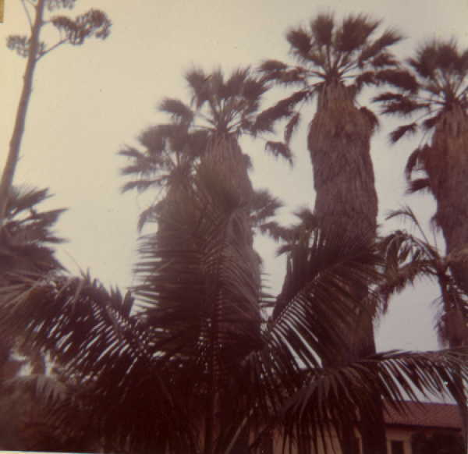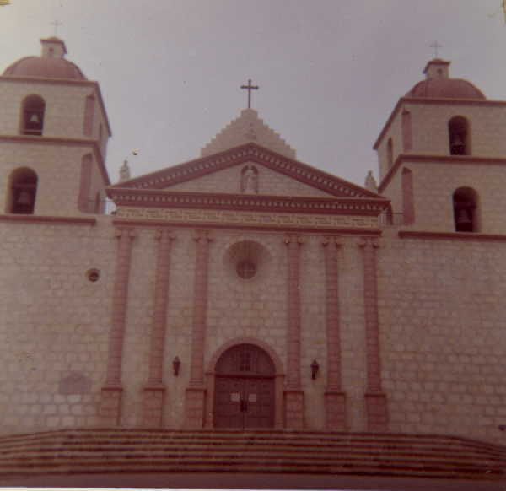

Santa Barbara Mission – California

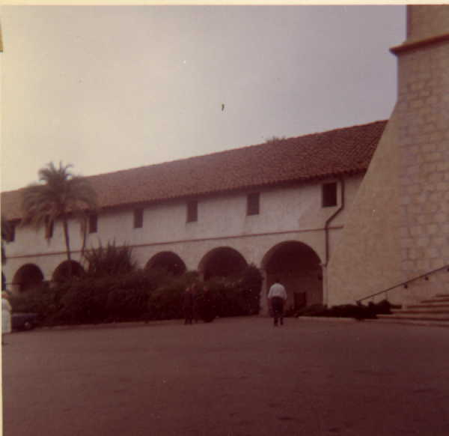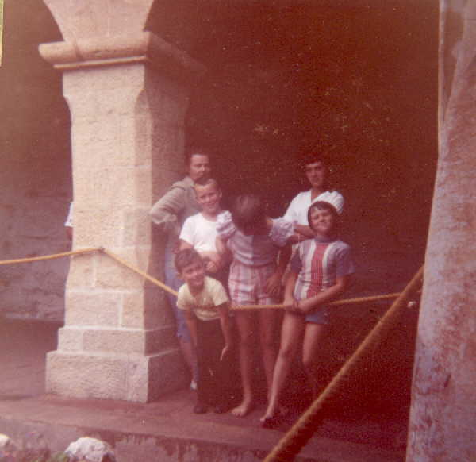

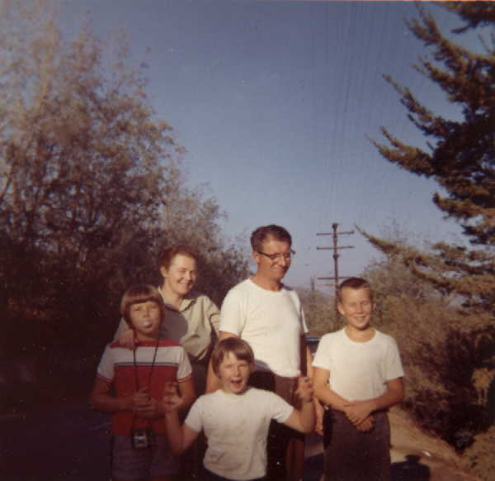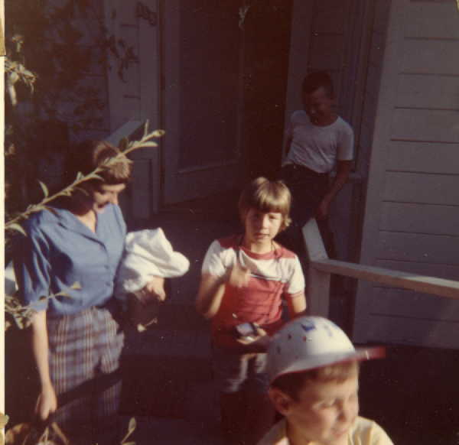
Liz, Johnny, Barbara, Joan & Jim Winter – Camarillo, Cal

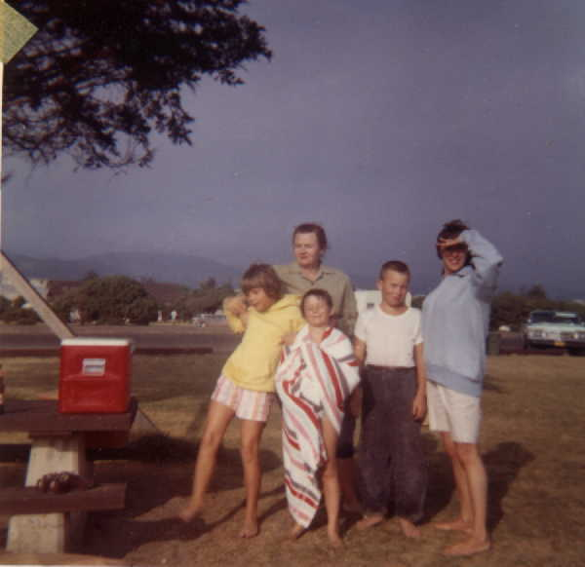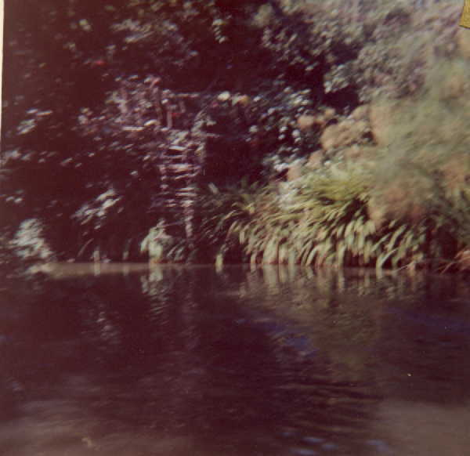
Carpenteria Beach on way to Santa Barbara Candid photo of submerged water buffalo –
-- free tables – free cooking gas et al -- jungle trip Disneyland
sexpot in blue - extra

Fri. Aug. 28
We started off at last for the place I wanted to go all along, Disneyland. Mommy, daddy and I went in Uncle John’s white truck. We drove up to the Disneyland Hotel and had lunch there.

After we parked the truck we boarded a train which took us from the parking lot to the place where you could get into Disneyland. The first ride we took was the train so that we could get a good look at the whole park. We saw a real Indian Village and stayed to see the Indians dance.

I drove a car all by myself and I took mommy and daddy for a boat ride. We went on a bobsled ride and it was scary. We rode a lot of things all day and drove home at night in the truck.

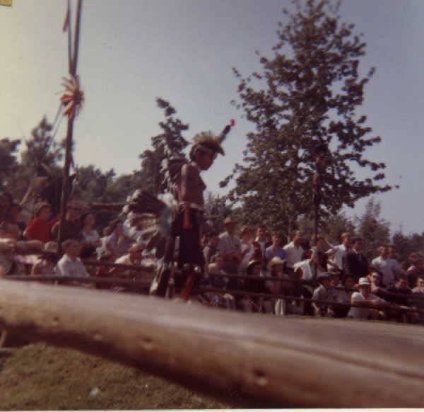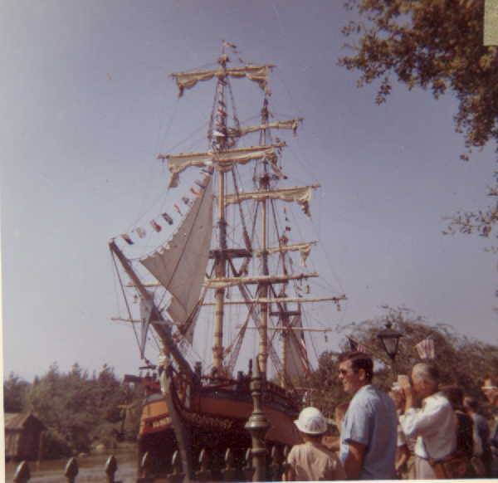
Injun war (or peace or rain) dance Pirate ship (no 50 cent tickets left)

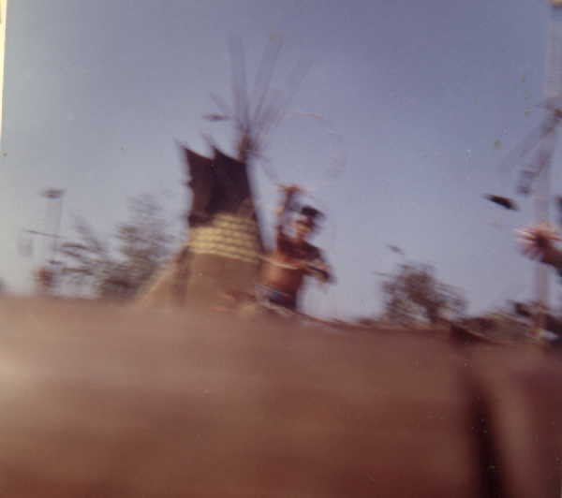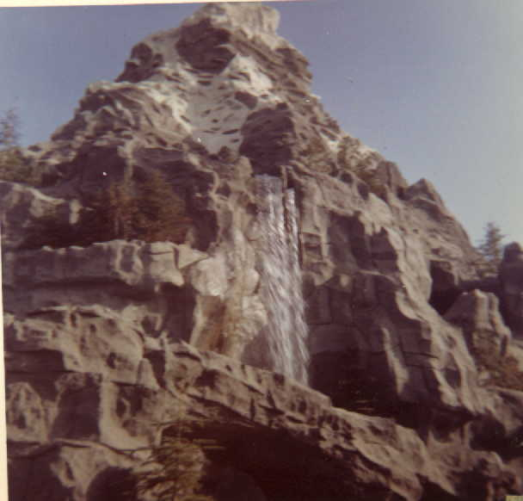
Bobsled ride in Matterhorn
(wait – 45 min)

Sat. Aug 29
Daddy, Uncle John, Jim and I went to visit a farm that grew a little bit of everything. We got plums and oranges, avocados, and other fruit that were new to me.

The Dausches came for us that afternoon and we started back across the country. We traveled through the desert at night planning to get to the Grand Canyon in the morning.

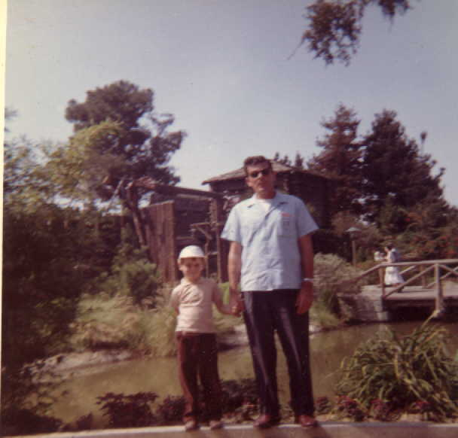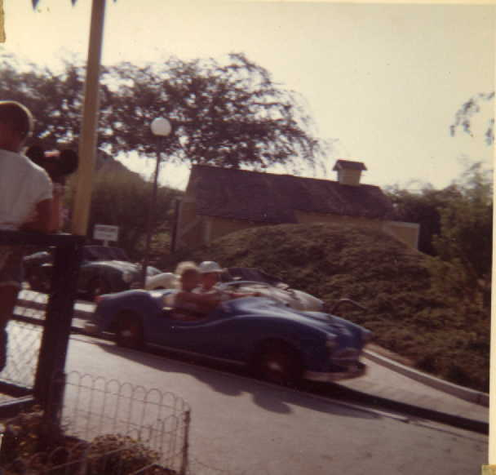
In front of Frontier Land. Lars & Ty California Freeway Training

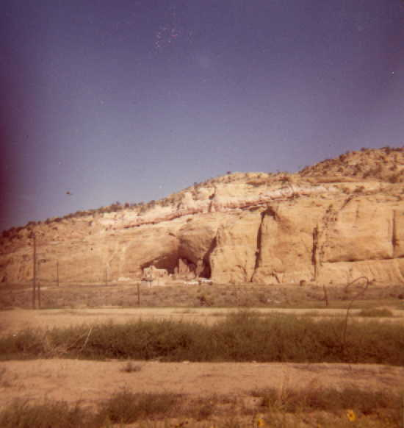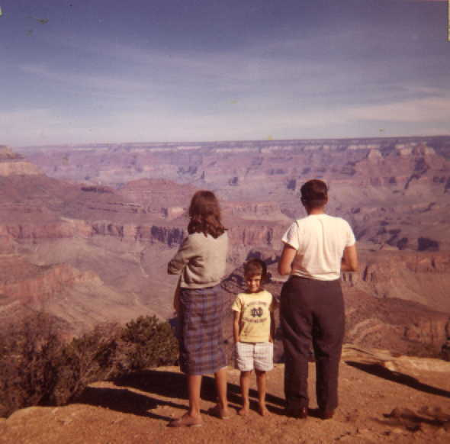
Cliff homes – New Mexico or Arizona Grand Canyon after all night drive.

Sun. Aug 30
We saw the Grand Canyon and we saw the Painted Desert and many Indians living in Hogans. We stopped at a motel in Winslow, Arizona. It had a swimming pool that was lots of fun.

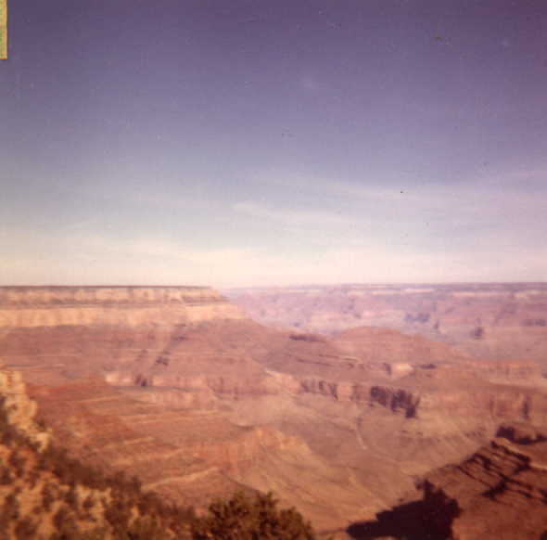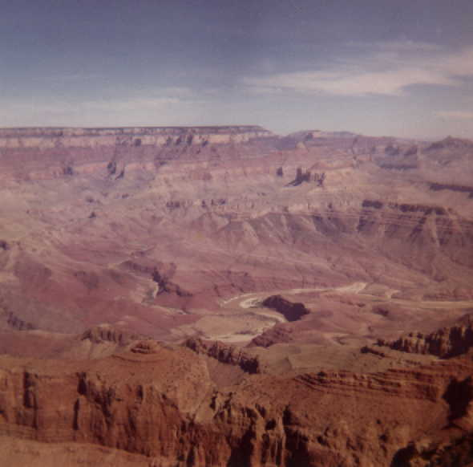

Grand Canyon in early morning light

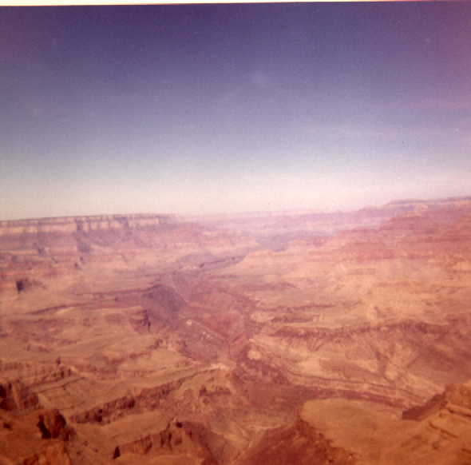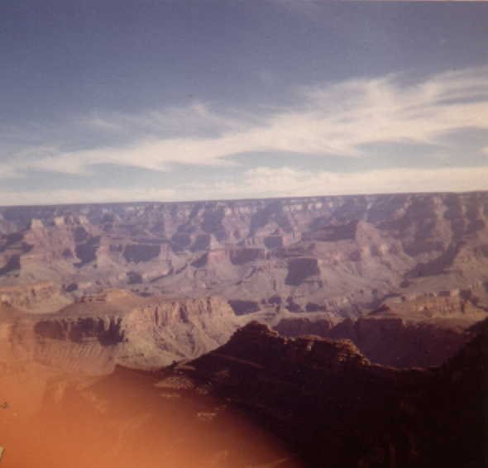

Monday, Aug 31
We traveled through New Mexico and stopped in Amarillo, Texas. The Bucking Bronco Motel had a swimming pool and horse rides.

Tues. Sept 1. We left Texas and drove through Oklahoma. We saw many oil wells.
We stopped at the Will Rogers museum. We saw many things about Will Rogers and even heard his voice on a record.
We stopped at another motel with a swimming pool in Joplin, Mo.

Wed. Sept 2.
We rode through Mo. and crossed the Miss. River at St. Louis. The river looked small at this point. We stopped in lower Ill. for the night.

Thurs. Sept. 3.
We are now in Indiana heading for Ohio where we hope to see the Amish colony.

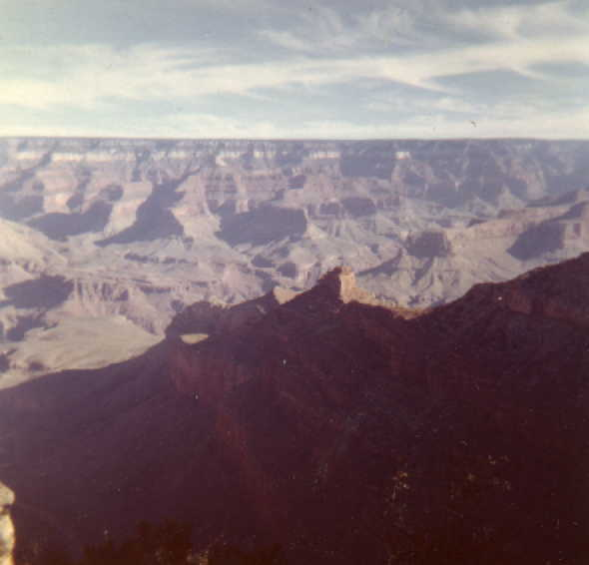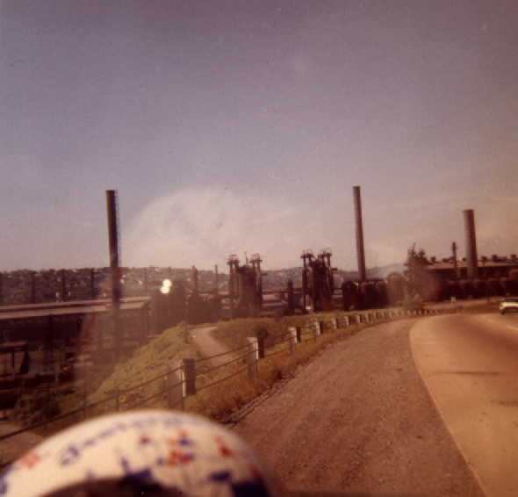
Grand Canyon Pittsburgh, Pa – steel mills idled in strike

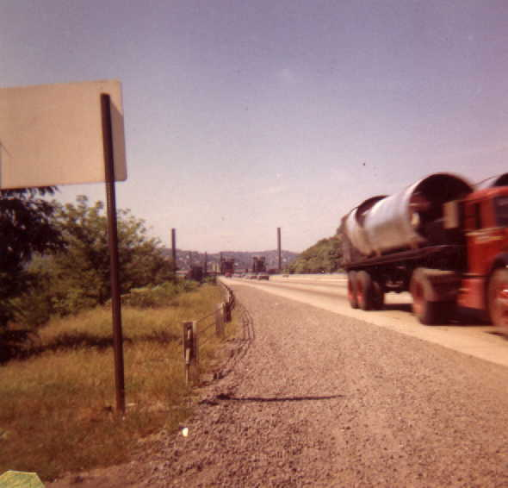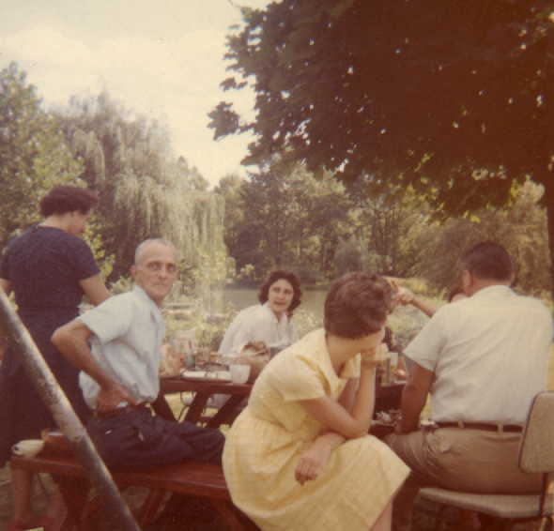
Pittsburgh, Pa Labor Day Picnic on return

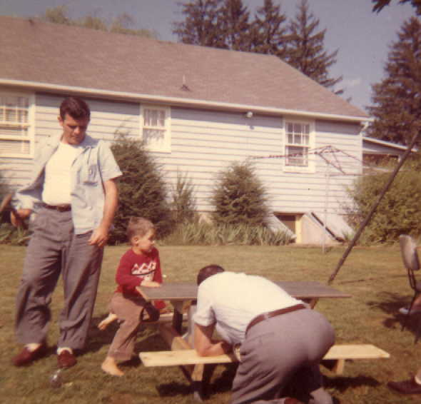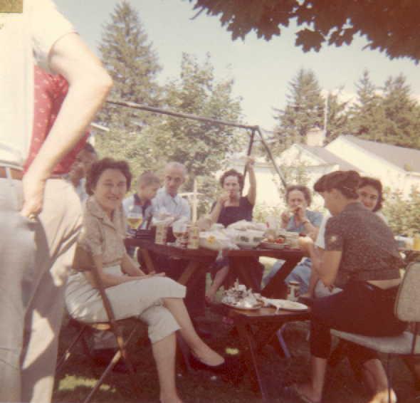
Assembling Ernie’s gift of a picnic table Labor Day Revels
for Lars

